***BLOG WRITING ON : -***

***TELECOMMUNICATION CHURN ANALYSIS ..***



I am going to write about complete end-to-end HR Telecommunication Churn Analysis project which would truly a guidance for all new comers who is aspirant of data science . when I accepted to go with data science and started learning about it I was in huge dilemma what to do, how to learn , how grab the knowledge, these are utmost common question that come to the everyone’s mind first who is willing to proceed their career with data science but since there so many helping blogs already written on internet by so many distinguished expert that helped me more than my expectation.I know there lots of blogs already there to help but in my project I will emphasized over some different points. Maybe,perhaps , my blog that I am going to write will help atleast a bit for all those who wants to be a data scientist .

So, please allow me to explain the agenda for this blog post. In this article, I have put down all the techniques in the form of sub-topics that I will be explaining one by one. And those pointers are as follows:  
  
1.      Problem Definition  
2.      Data Analysis  
3.      EDA  
4.      Pre-processing Data  
5.      Building Machine Learning Models  
6.     Concluding Remarks

Let’s start with the problem definition or a short introduction on the project that I have chosen to elaborate and why it was made in the first place.

**1.Problem Defination**

All telecom companies faces churn from customers. Customer churn is defined as when customers or subscribers discontinue doing business with a company. Customers in the telecom industry can choose from a variety of service providers and actively switch from one to the next. It is a problem for telcommunication companies as it is very expensive to acquire new customers and companies want to retain their existing customers. We were provided with cleaned customer activity data (features), along with a churn label specifying whether a customer canceled the subscription.

Our analysis can help understand how customer churn is related to other features , find out what could be the reason for the churn and provide some recommendations for better customer retention rate.



Churn, sometimes also called attrition, is the percentage of customers that stop utilizing a service It is often used to measure businesses which have a contractual customer base, especially subscriber-based service models. Customer churn in the telecom industry poses one of the most significant risks to loss of revenue. The average churn rate in the telecom industry is approximately 1.9% per month across the four major carriers, but could rise as high as 67% annually for prepaid services*. Since the cost of acquiring new customers is significantly higher than the cost of retaining them, fostering customer loyalty is key.

Therefore the major goal of this project is to identify the “Churn” rate as a simple Yes or a No tag making this to be a classification problem!

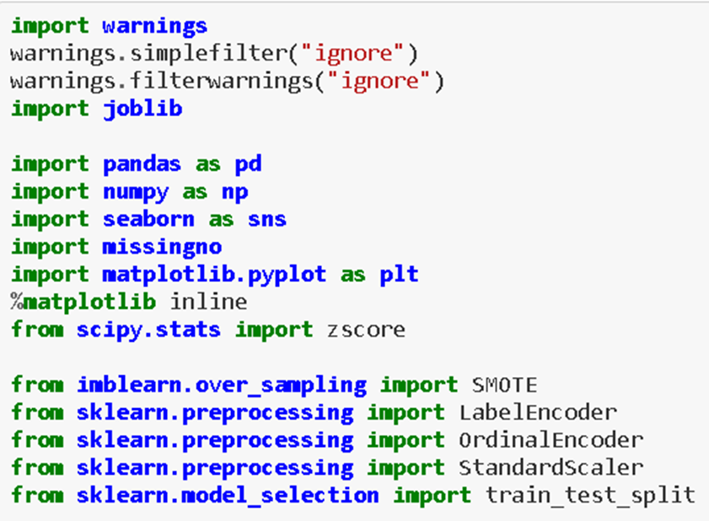

First of all I have imported all the necessary libraries or tools that is sure going to come into help of building best machine learning model. I have to import whole the dataset into single jupytor notebook that we can apply upon various method and machine learning Algorithm.

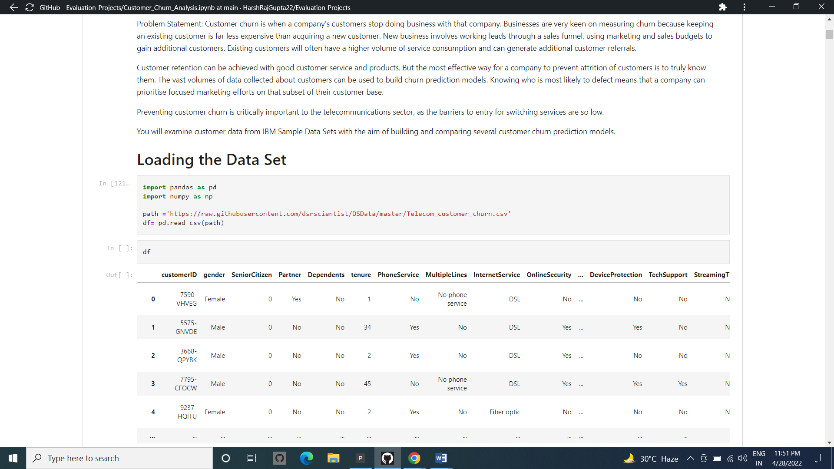

From the above read_csv method we have imported entire dataset into jupyter notebook and stored into single variable name as df.

**2.Data Analysis-**

In this section of our project we will look at every columns of our data set and we will try to figure out which column is truly related to solve of problem statement or not .

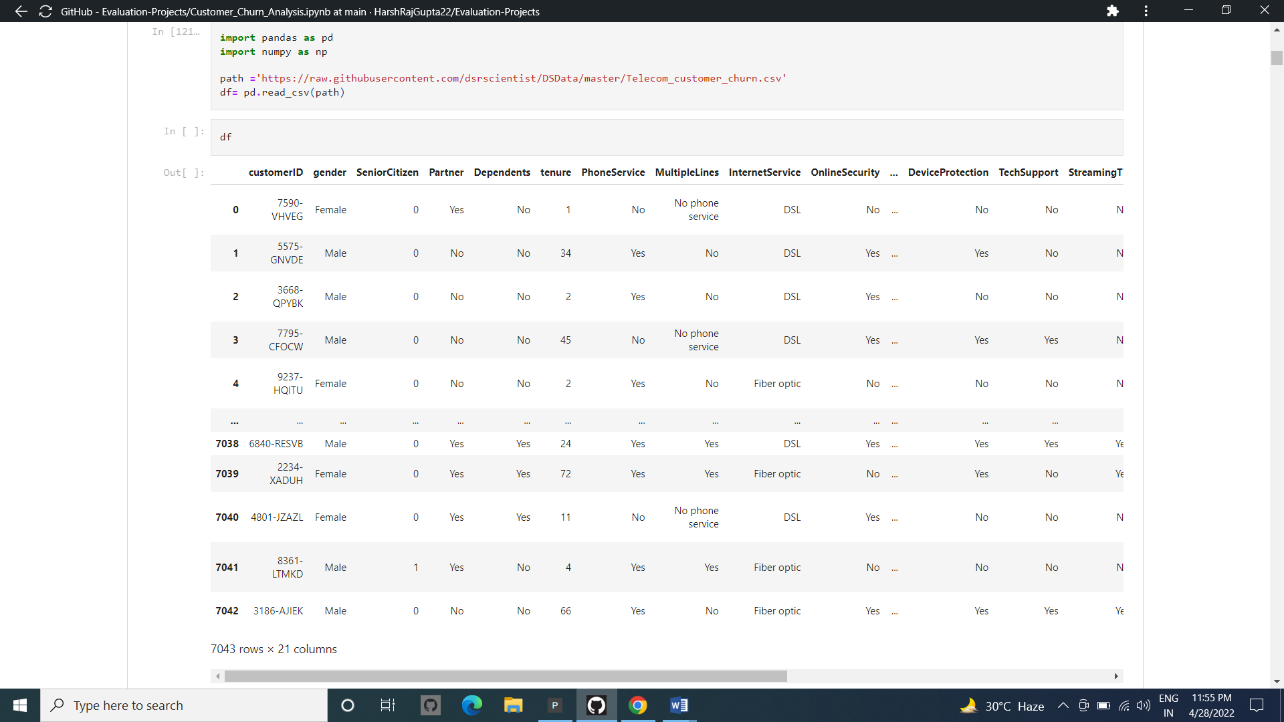

As we have dataset having 7043 rows and 21 columns below .in this 21 columns one is our target means Churn and rest are features.

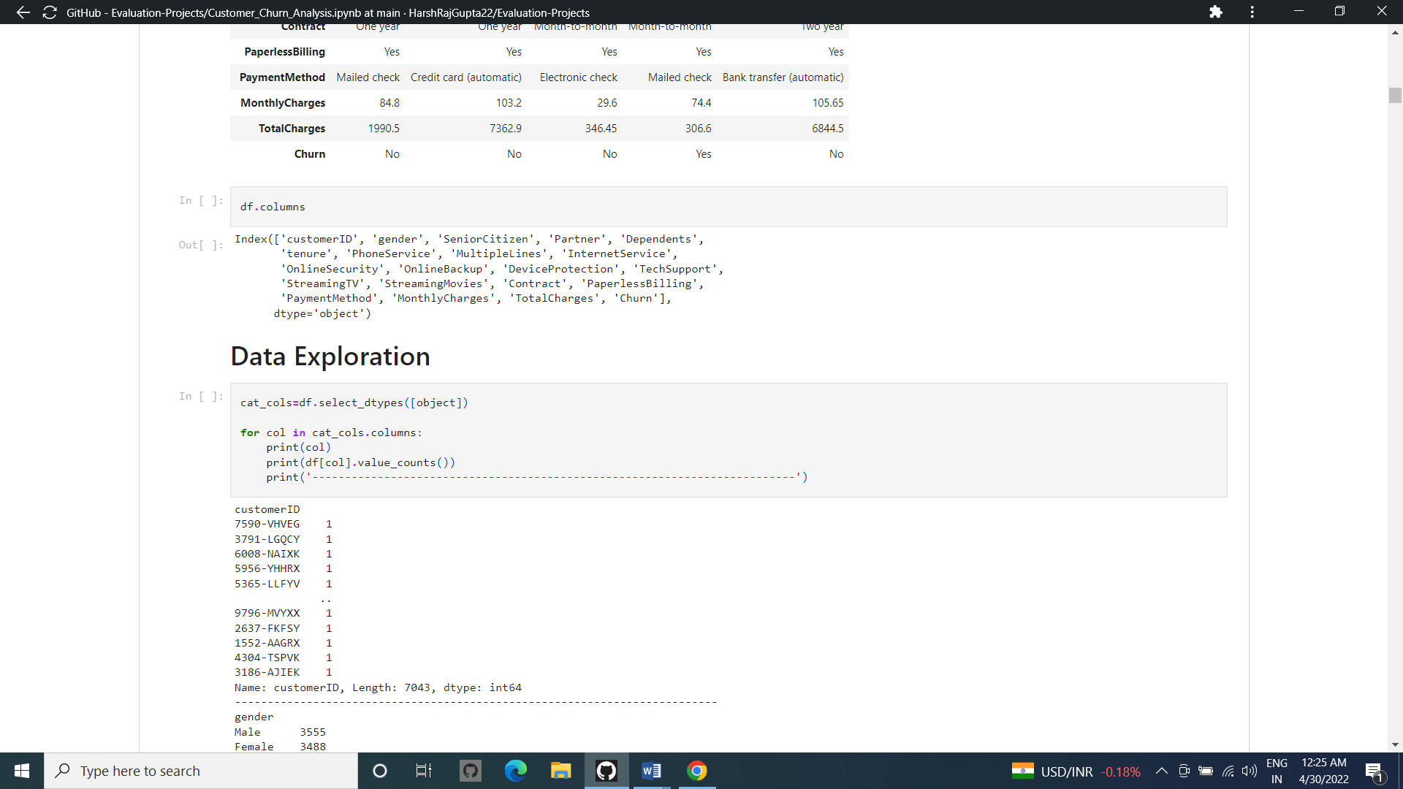

Above the method I have used to find the uniqueness present in our dataset but this method has some limit means it does not give the information of uniqueness for categorical data. That method was only useful for the numerical data.

So, avoiding that limitation I have used loop method for the object data type object.

Now we need to analyse the data on the basis of the data types present ..

We Go for futher deep details Of each and every Columns Present

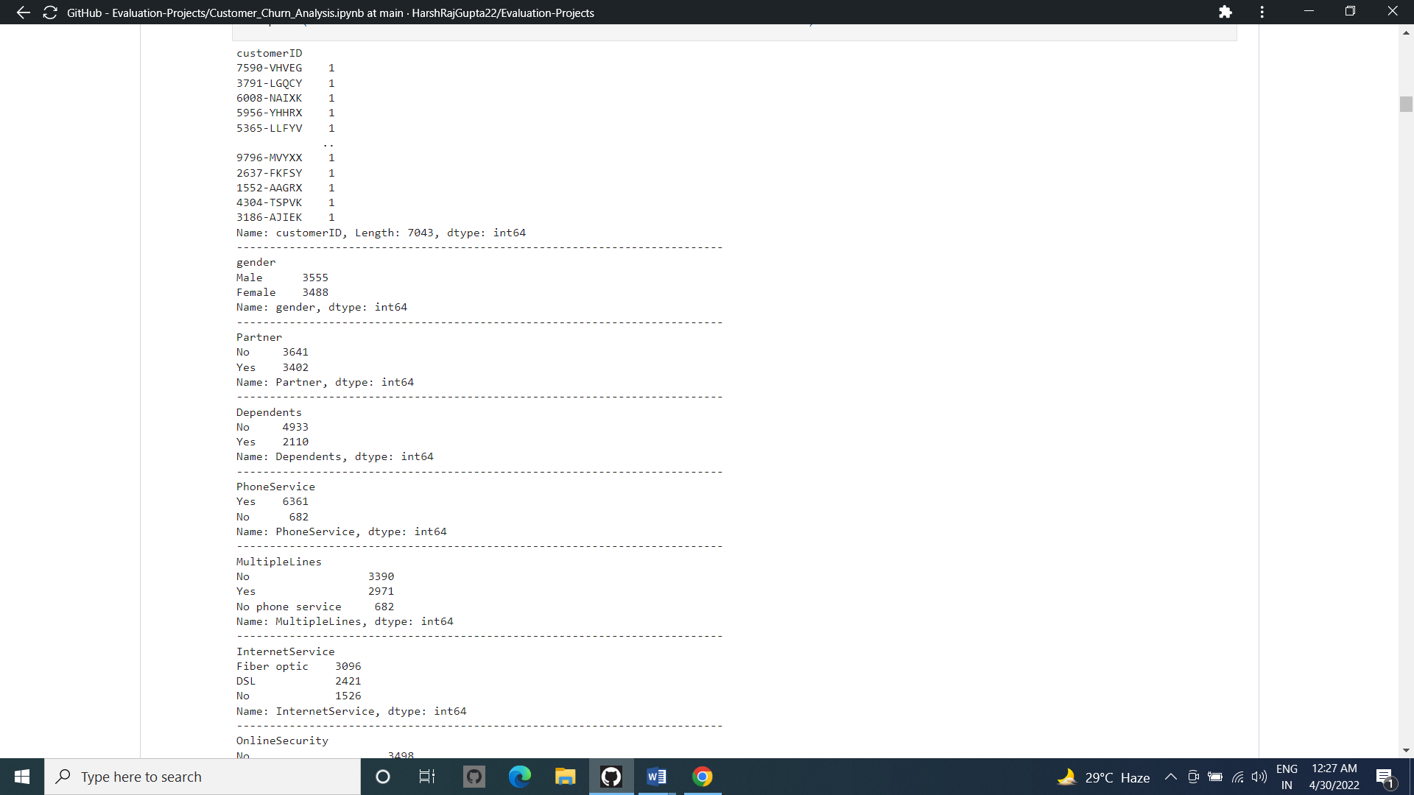

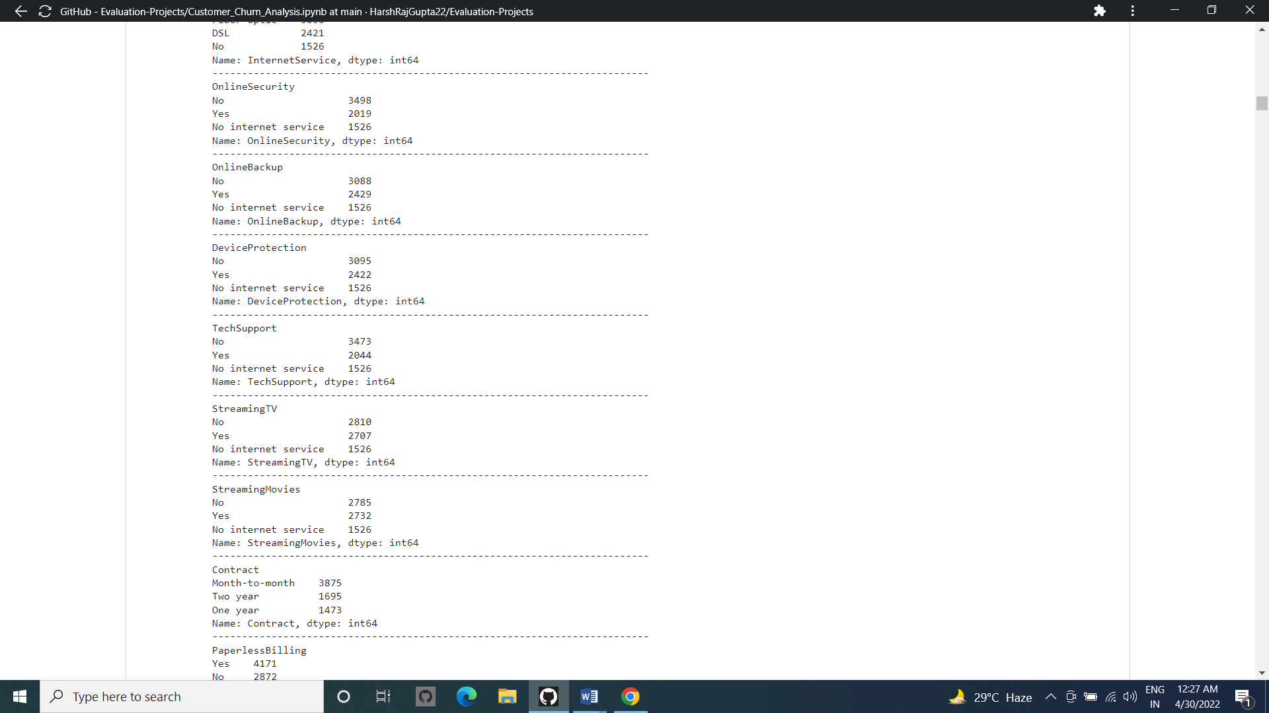

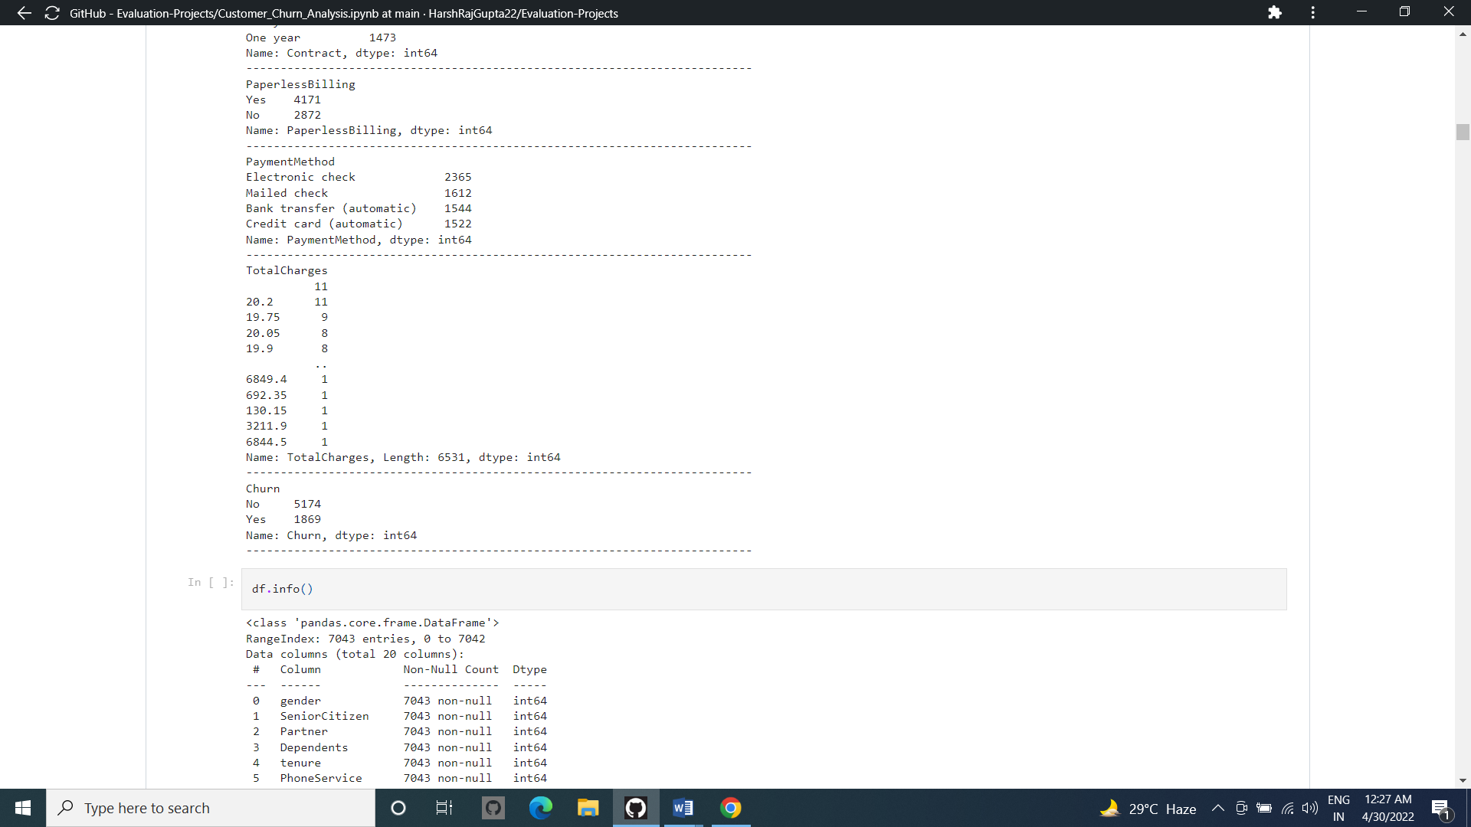

From the Above we came to know about the number of Unique Counts of categorical Columns and there Details Of number of Unique Counts in it

**3. EDA**

After loading the dataset we applied various functions on the data.We checked for discrepencies and consistency of data .Thereafter we analysed each variable seperately to understand them thoroughly.Then we did Multivariate analysis by comparing our target variable that is ‘Churn’ with other independent variables. This process helped us figuring out various aspects and relationships among the target and the independent variables. It gave us a better idea of which feature behaves in which manner compared to the target variable.

Without any hesitation we can say that EDA, that is Exploratory Data Analysis is heart for building of machine learning model . This is the utmost important part that every dataset must be go through it . EDA is process use various of produre or method to make our dataset into appropriate format so we can achieve our real target. In this EDA we do entire dataset analysis via using various using tools and python libraries.

From the below picture, i can explain:

1. For any sort of Machine learning Model data is the most important thing that you must have .There are so many way to collect the data. I will not go into depth here but I can say primary and secondary there two are the main sources of data collection
2. Then I sorted the entire data as per their features and Arrange into some format
3. By the different means of visualization technique, I have visualized the data and find a way to explain the whole story.

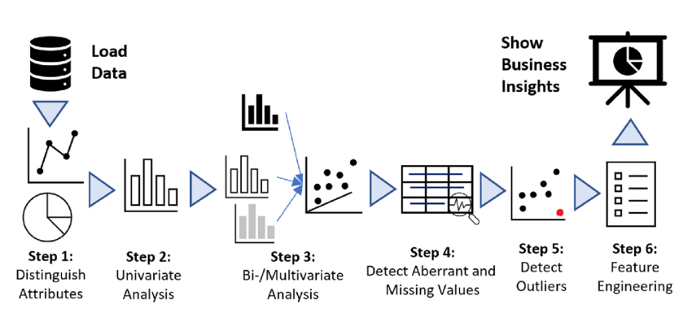

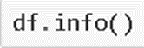

Getting an overview of the Data Type and a summary of the Data set present

This df.info () method gave us all information regarding of types of our dataset.

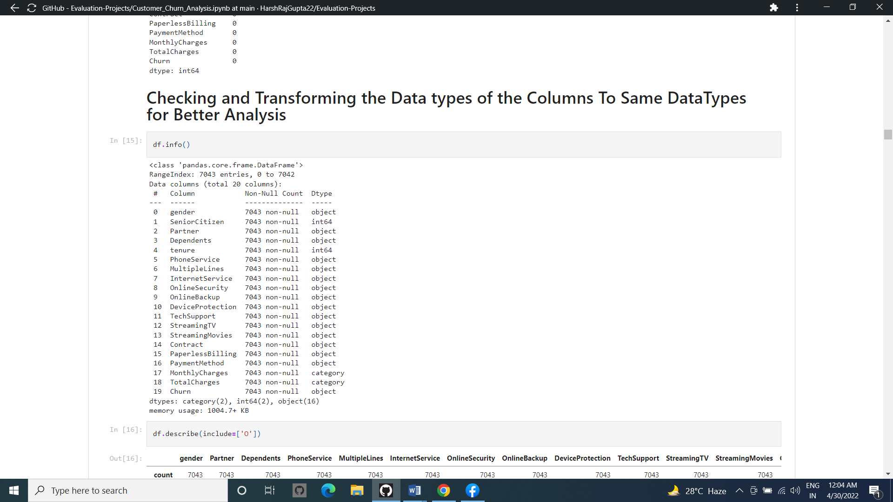

This df.info () method gave us all information regarding of types of our dataset.

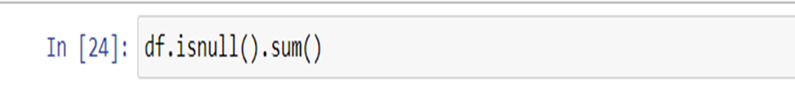

This isnull() method with sum function allow us to figure out the missing value present in our dataset .

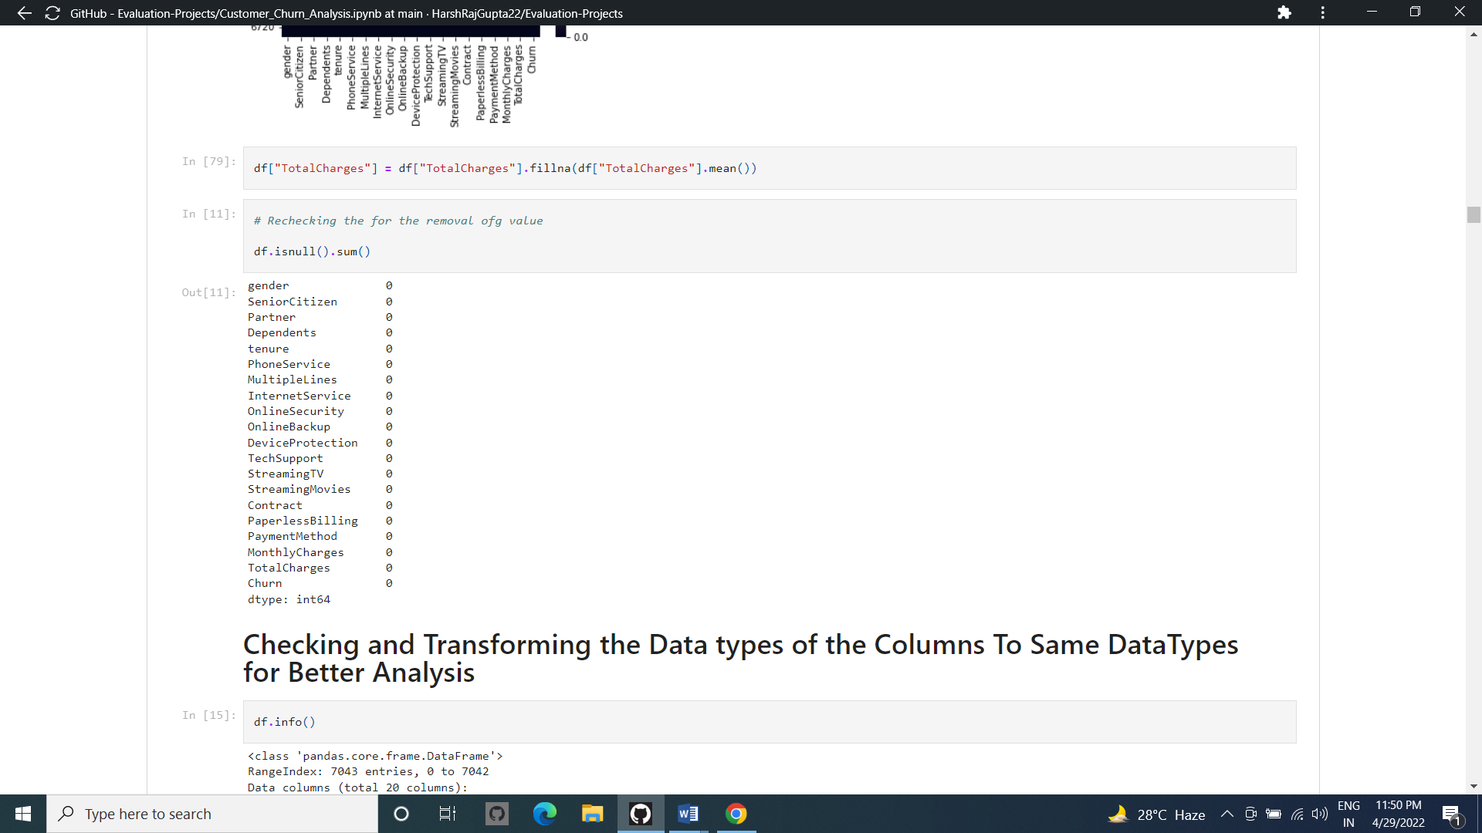

Now, fortunately we dont have any null value present in dataset

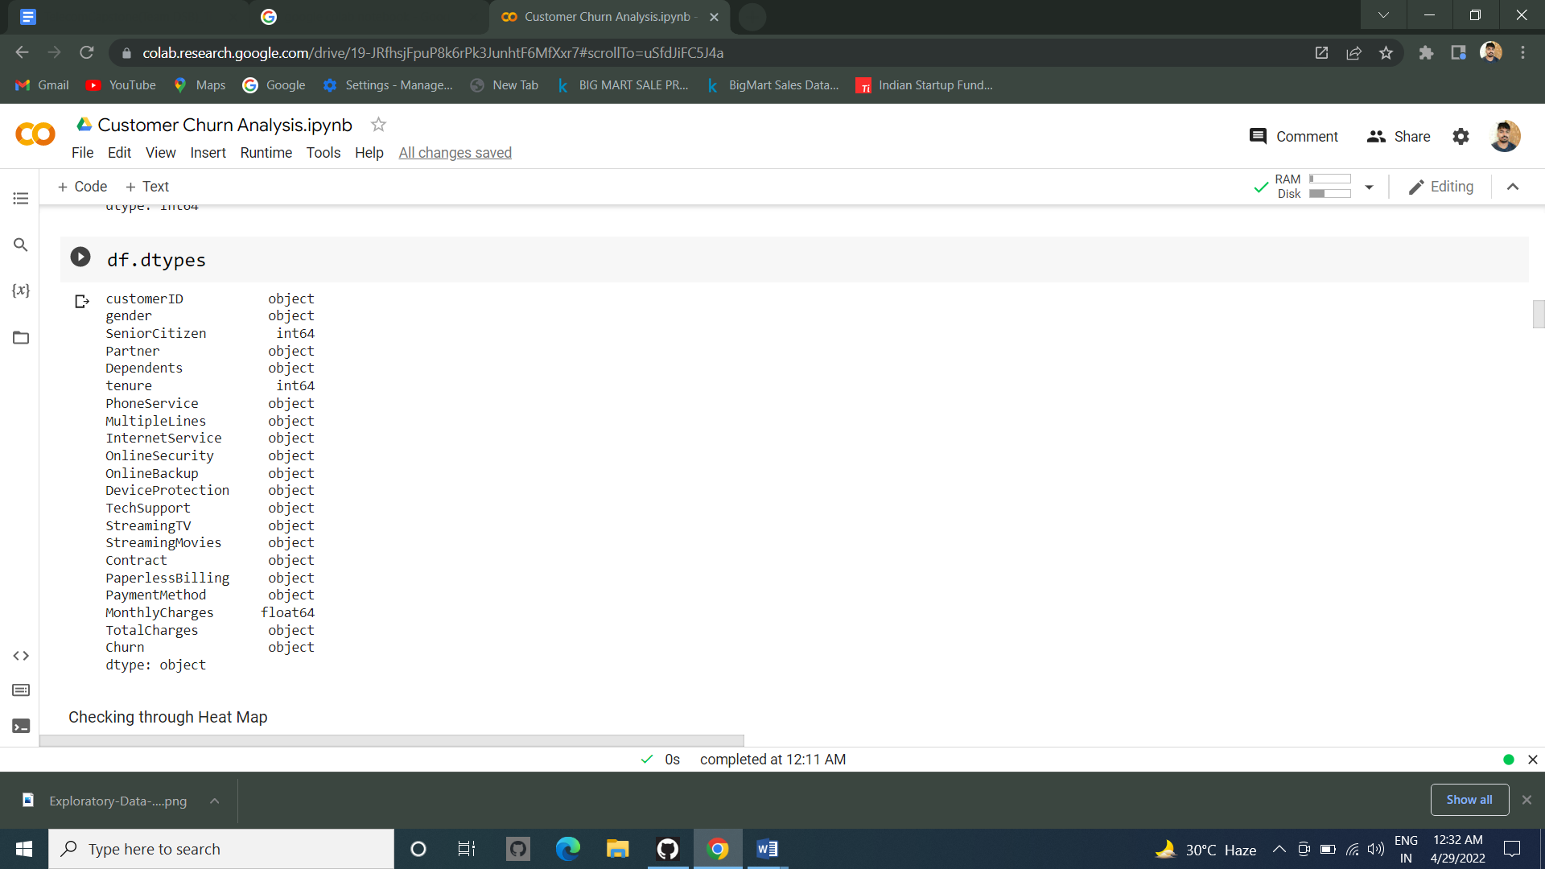

We Now Need to check the Columns Data types in the data set which will help us in easy analysis of the Dataset

As we can see that the data types are in mix form which consists of all the datatypes columns within it so we no need to make all Into one type..

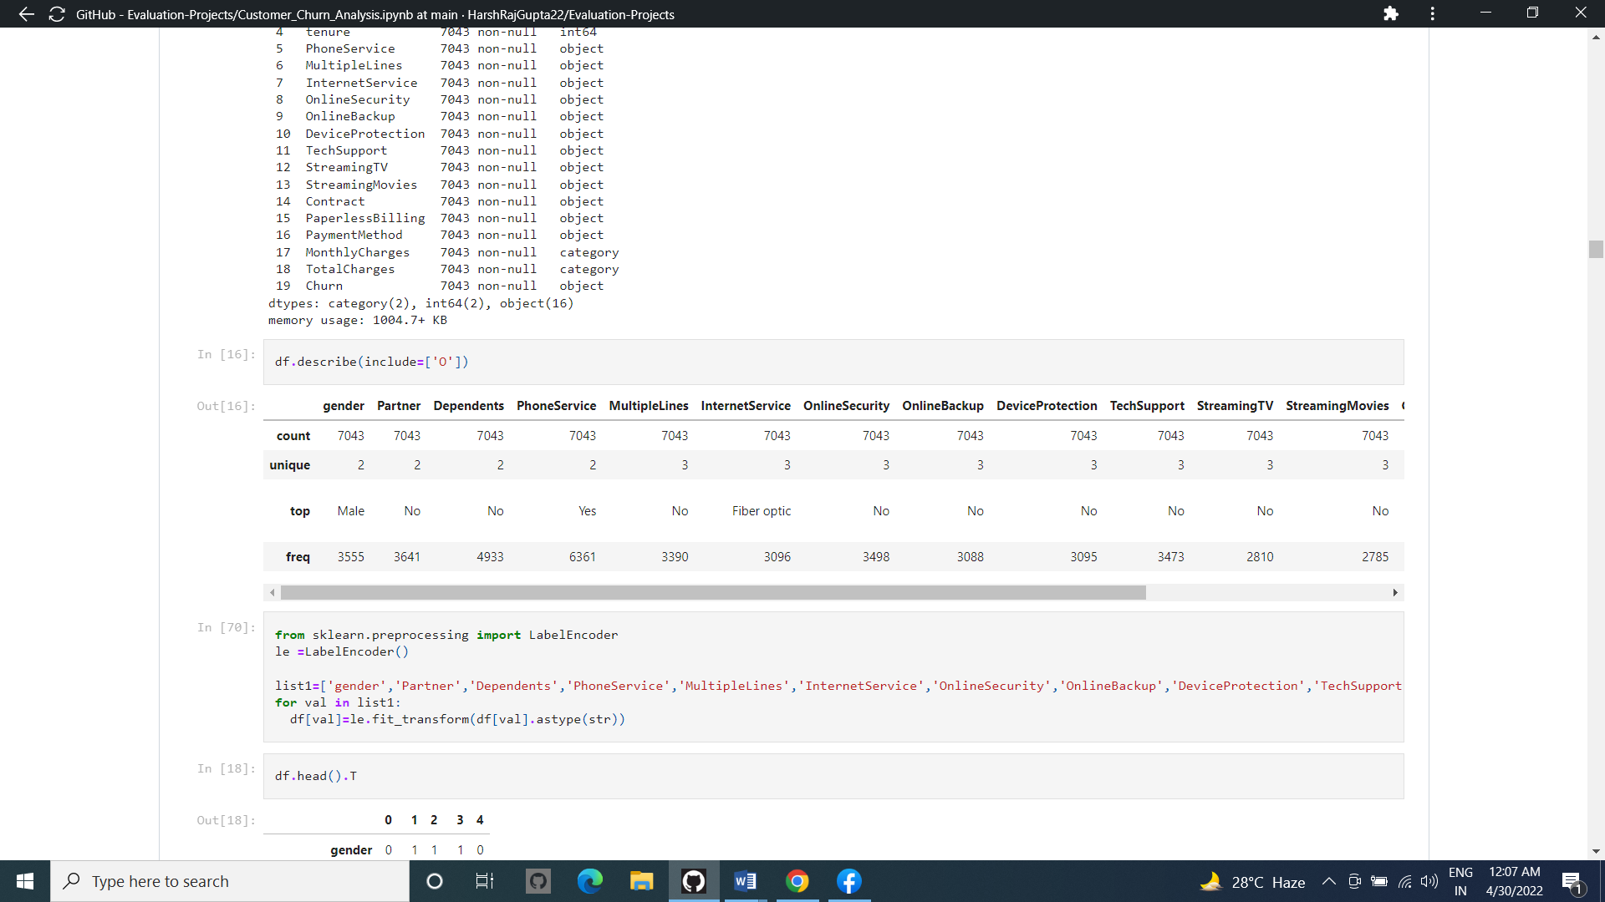

We now check the no. of Unique Counts in the rows..



Changing the data type from categorical to numerical Columns For Easy Analysis of the Datas..

Uni-Variate Analysis : -

Univariate analysis looks at one feature at a time. When we analyze a feature independently, we are usually mostly interested in the distribution of its values and ignore other features in the dataset. The easiest way to take a look at the distribution of a variable is to plot its histogram using the Data Frame's method hist (). Many interesting insights came to light while performing univariate analysis of each variable , which are documented in the business insights section.

Multi-Variate Analysis : -

Multivariate plots allow us to see relationships between two and more different variables, all in one figure. Just as in the case of univariate plots, the specific type of visualization will depend on the types of the variables being analyzed. We performed Bi Variate Analysis on our variables with Churn as our Pivot .

We plotted a Correlatuion matrix to visualize the correlations among the variables in our dataset. This is important to know to decide which of the variables are influencing Churn. First , we used the method corr() on a Data Frame that calculates the correlation between each pair of features. Then, we passed the resulting correlation matrix to heatmap () from seaborn , which rendered a color-coded matrix for the provided values. Thereafter we used different visualisation techniques to try and understand the how the variables with high correlation to Churn are affecting customer

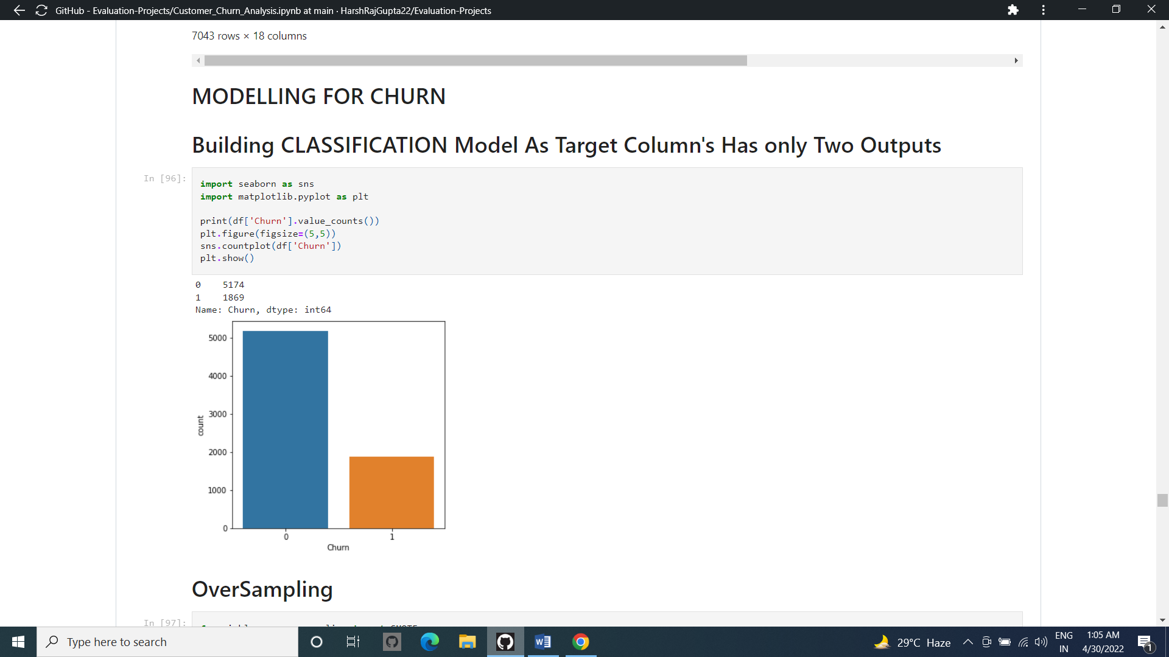

We can see that the Customers Leaving the Company is Higher Than non Leaving Ones..

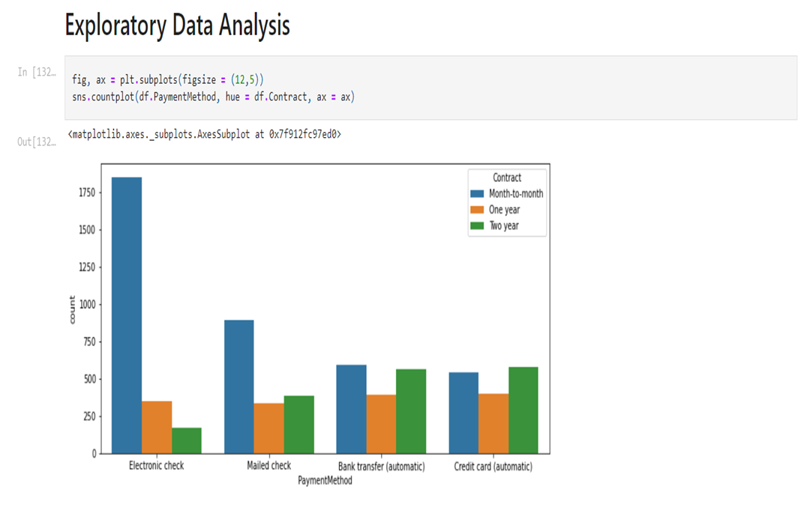

People having month-to-month contract prefer paying by Electronic Check mostly or mailed check. The reason might be short subscription cancellation process compared to automatic payment.

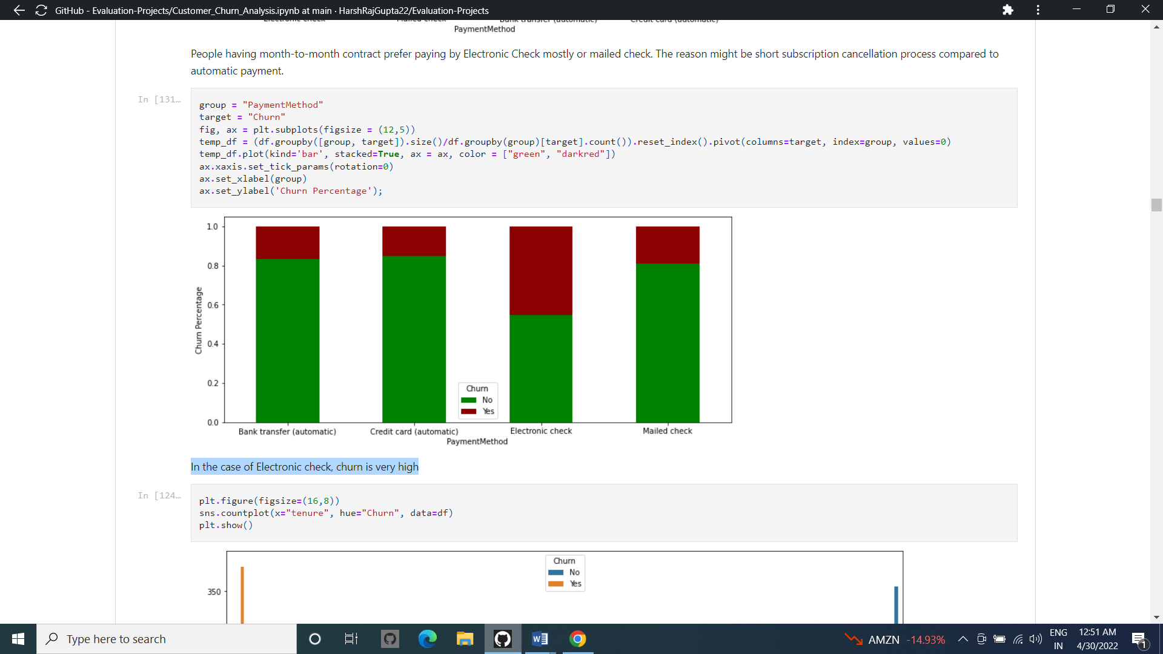

In the case of Electronic check, churn is very high

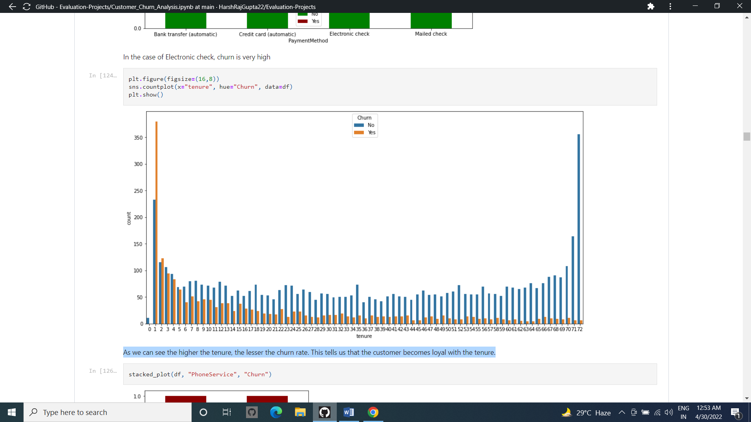

As we can see the higher the tenure, the lesser the churn rate. This tells us that the customer becomes loyal with the tenure.

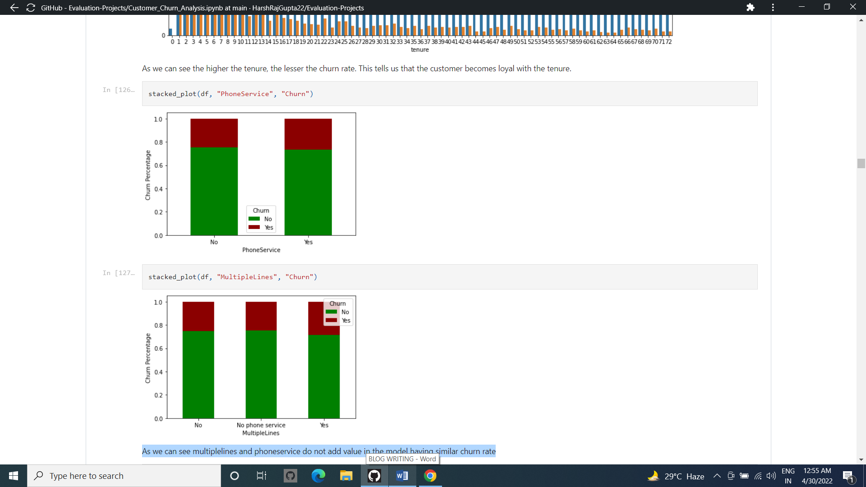

As we can see multiplelines and phoneservice do not add value in the model having similar churn rate

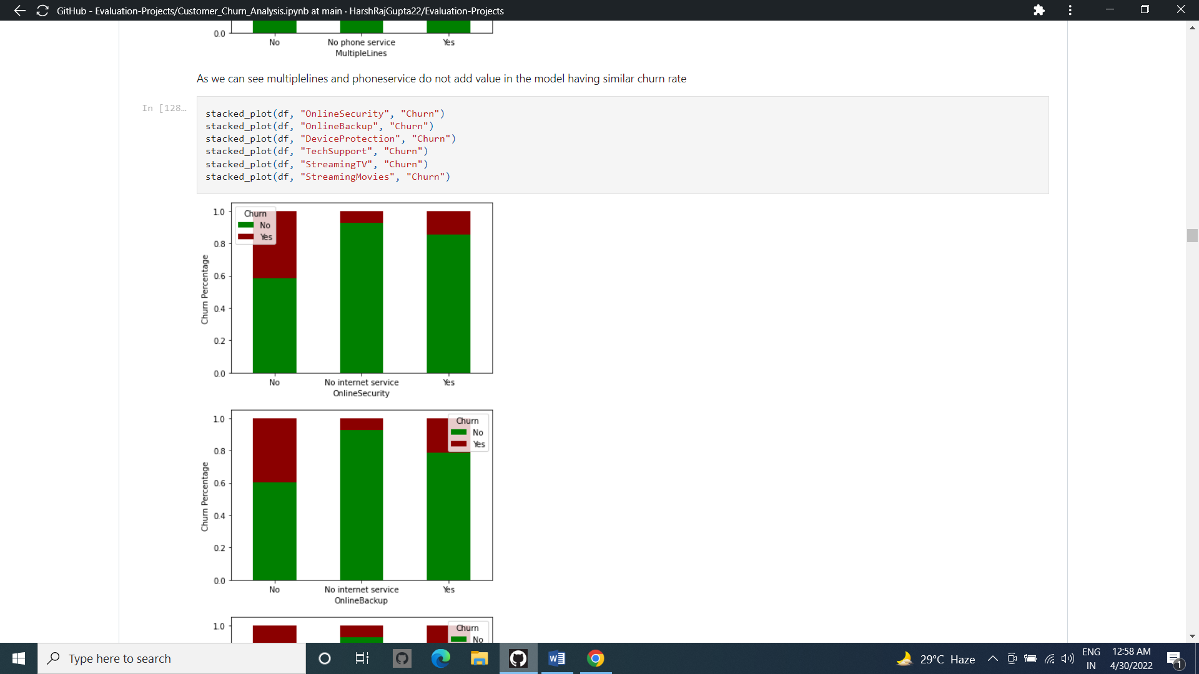

If a person does not opt for internet service, the customer churning is less. The reason might be the less cost of the service. Also, if they have internet service and does not opt for specific service their probability of churning is high.

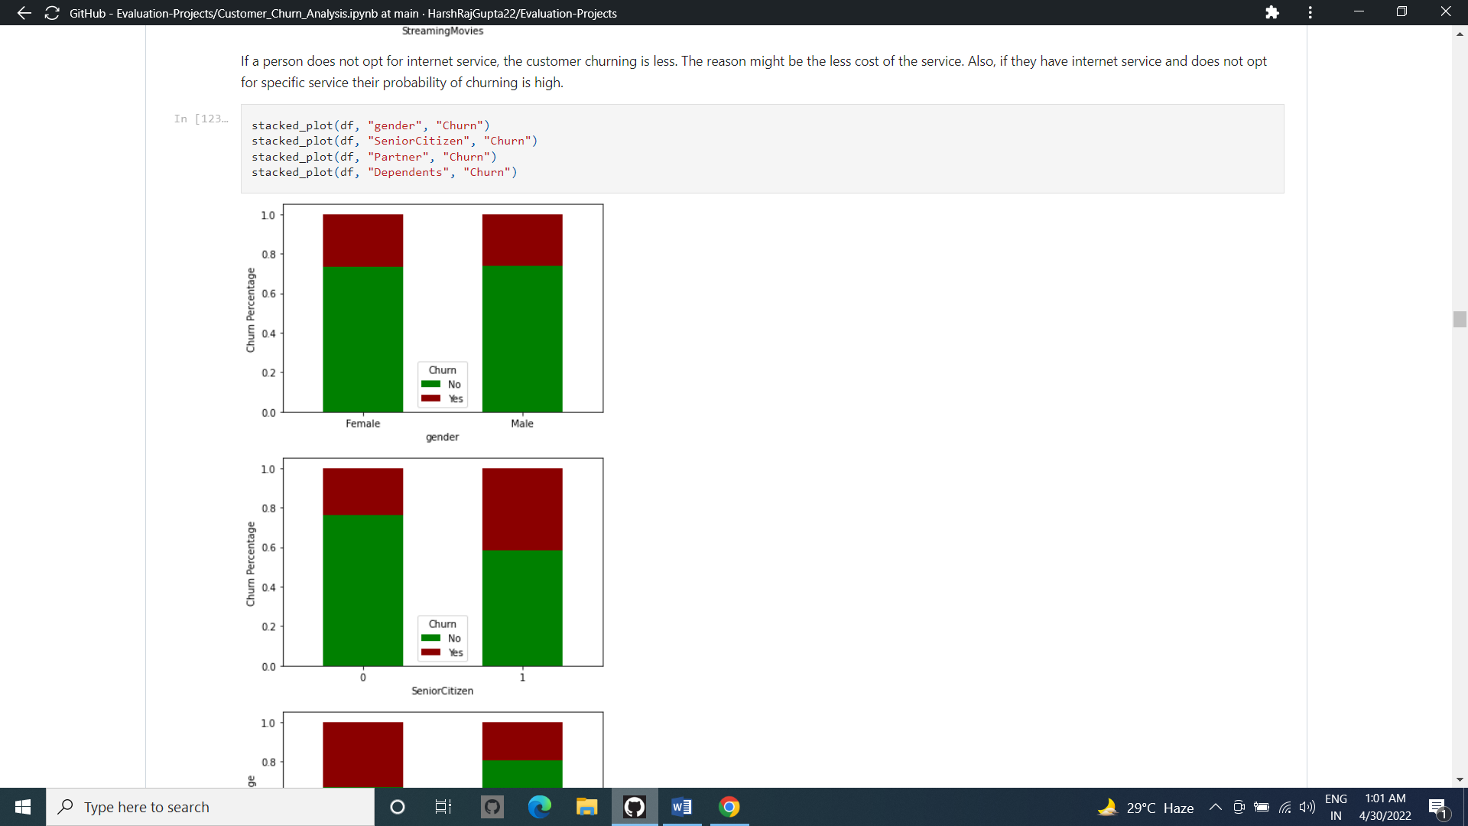

* Observations
  + Gender alone does not help us predict the customer churn.
  + If a person is young and has a family, he or she is less likely to stop the service as we can see below. The reason might be the busy life, more money or another factors.
  + Mostly people without dependents go for fiber optic option as Internnet Service and their churning percentage is high.

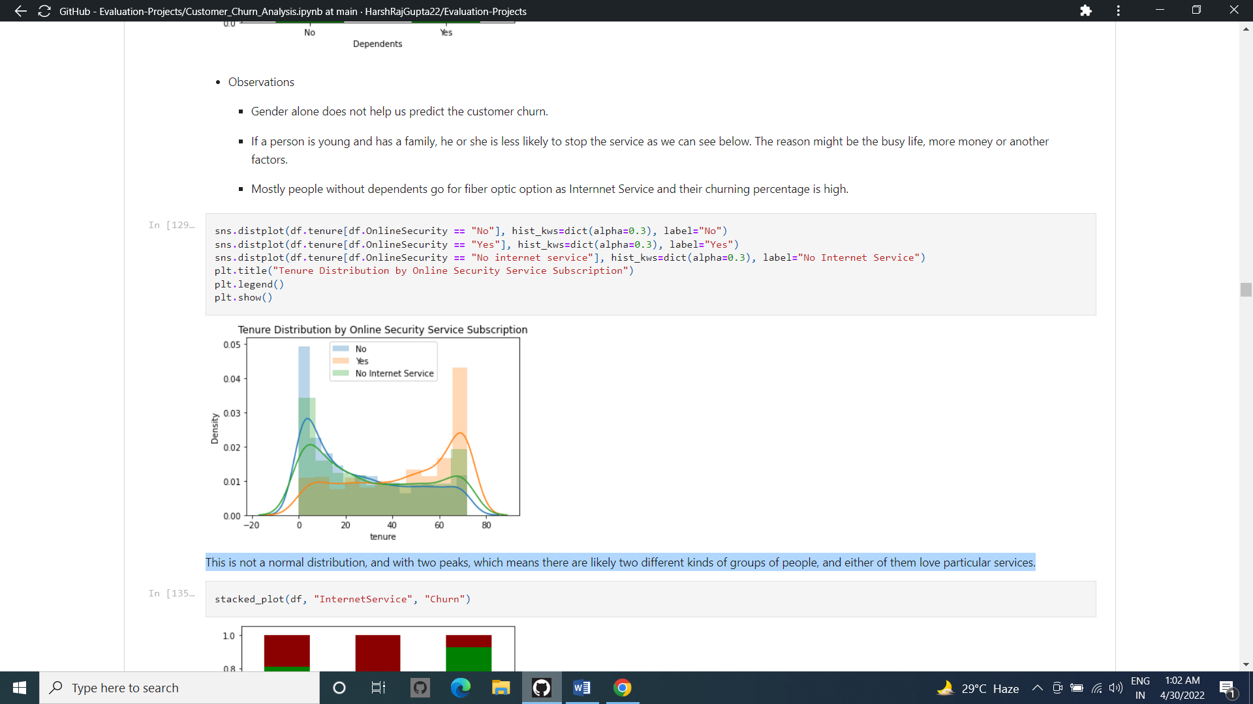

This is not a normal distribution, and with two peaks, which means there are likely two different kinds of groups of people, and either of them love particular services.

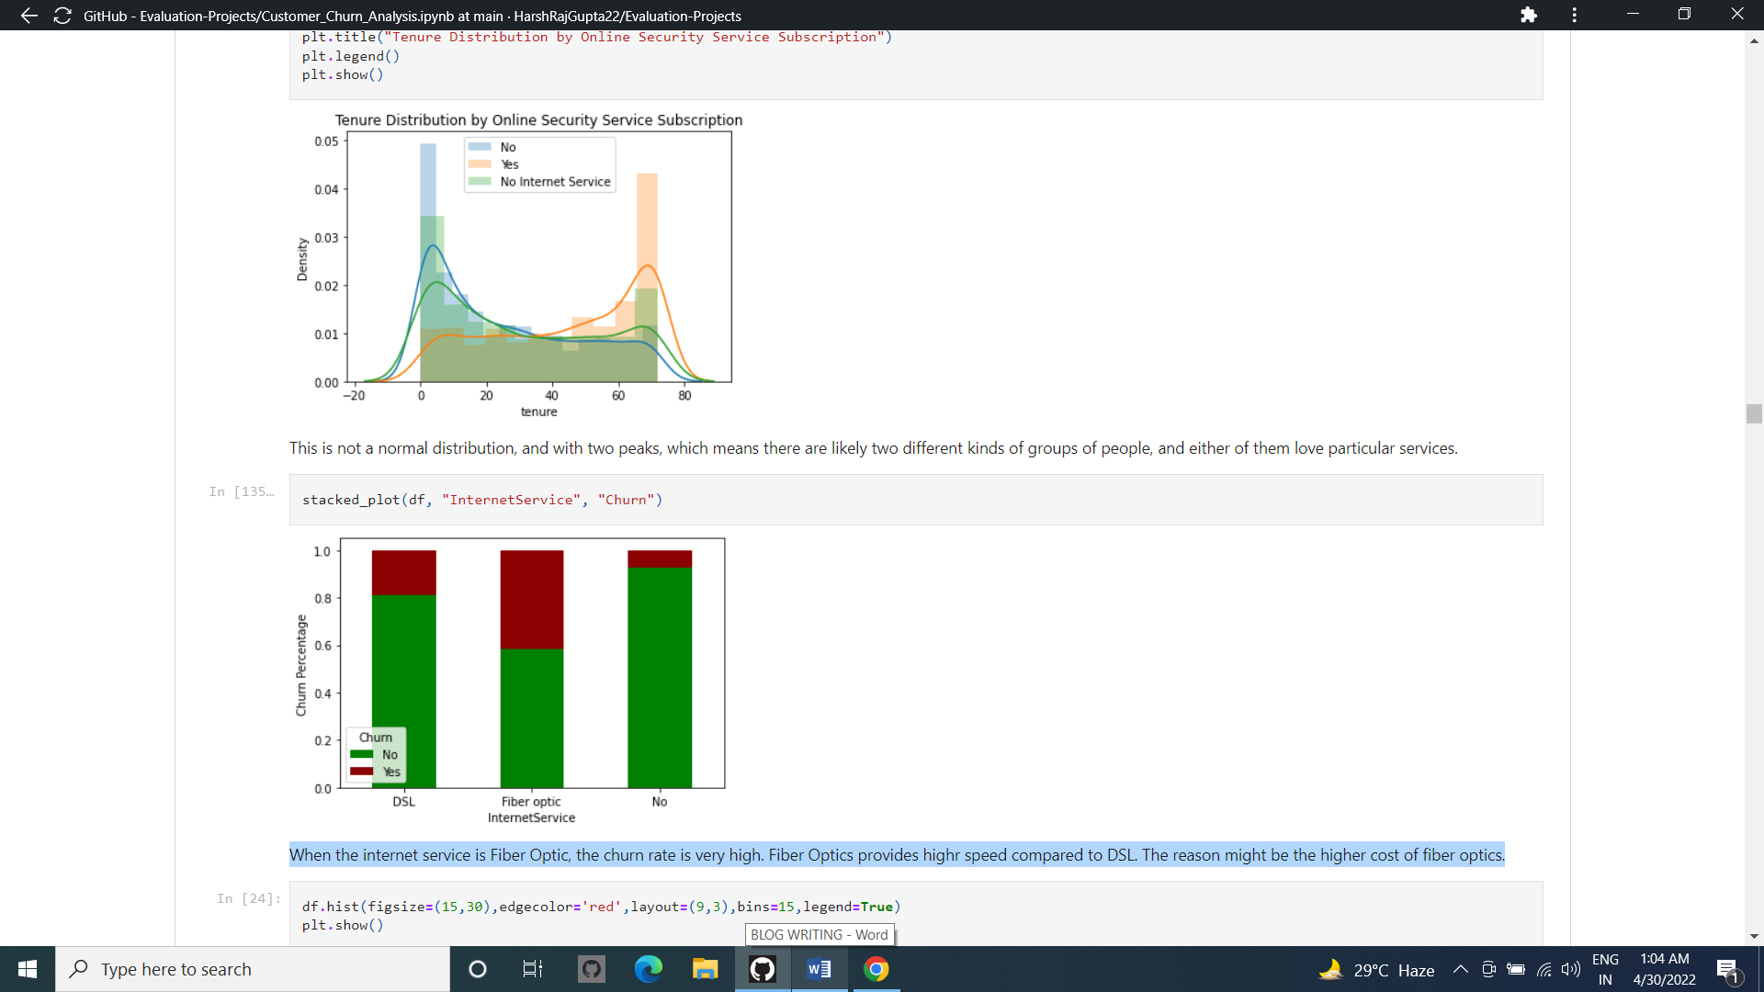

When the internet service is Fiber Optic, the churn rate is very high. Fiber Optics provides highr speed compared to DSL. The reason might be the higher cost of fiber optics.

OBSERVATIONS : -

1. 14.49% of customers have left the company.

2. We can infer that people from state are enjoying telecom service most among all other states.

3. Customers with no plan churn the most. International plan subscribers tend to churn more compared to the voice mail plan customers as the cost for international calls are more compared to voice mail.

4. Customers with international plans are charged at almost the same rate as customers with no

international plan.

5. Customers with more customer service calls are definitely churning the company.

6. The mean of the total charge is 12.3 % more for customers who churned compared to the

customers who did not churn .

7. Customers above account length of 150 are less in number compared to those below account length of 150 and all customers are churning irrespective of the account length.

8. Based on the analysis it can be said that the Churn customers are paying significant tariff mostly during the day hours even though the duration of call minutes is the least among three.

1. **Pre-Processing**

Data processing is a processes of preparing the raw data and making it suitable for it a machine learning model. It is the first and crucial step while creating a machine learning model.

When creating machine learning project it is note always a case that become across the clean and formatted data and while doing any operation with data it is a mandatory to clean it and put in formatted way. So, for this we use data pre-processing task.

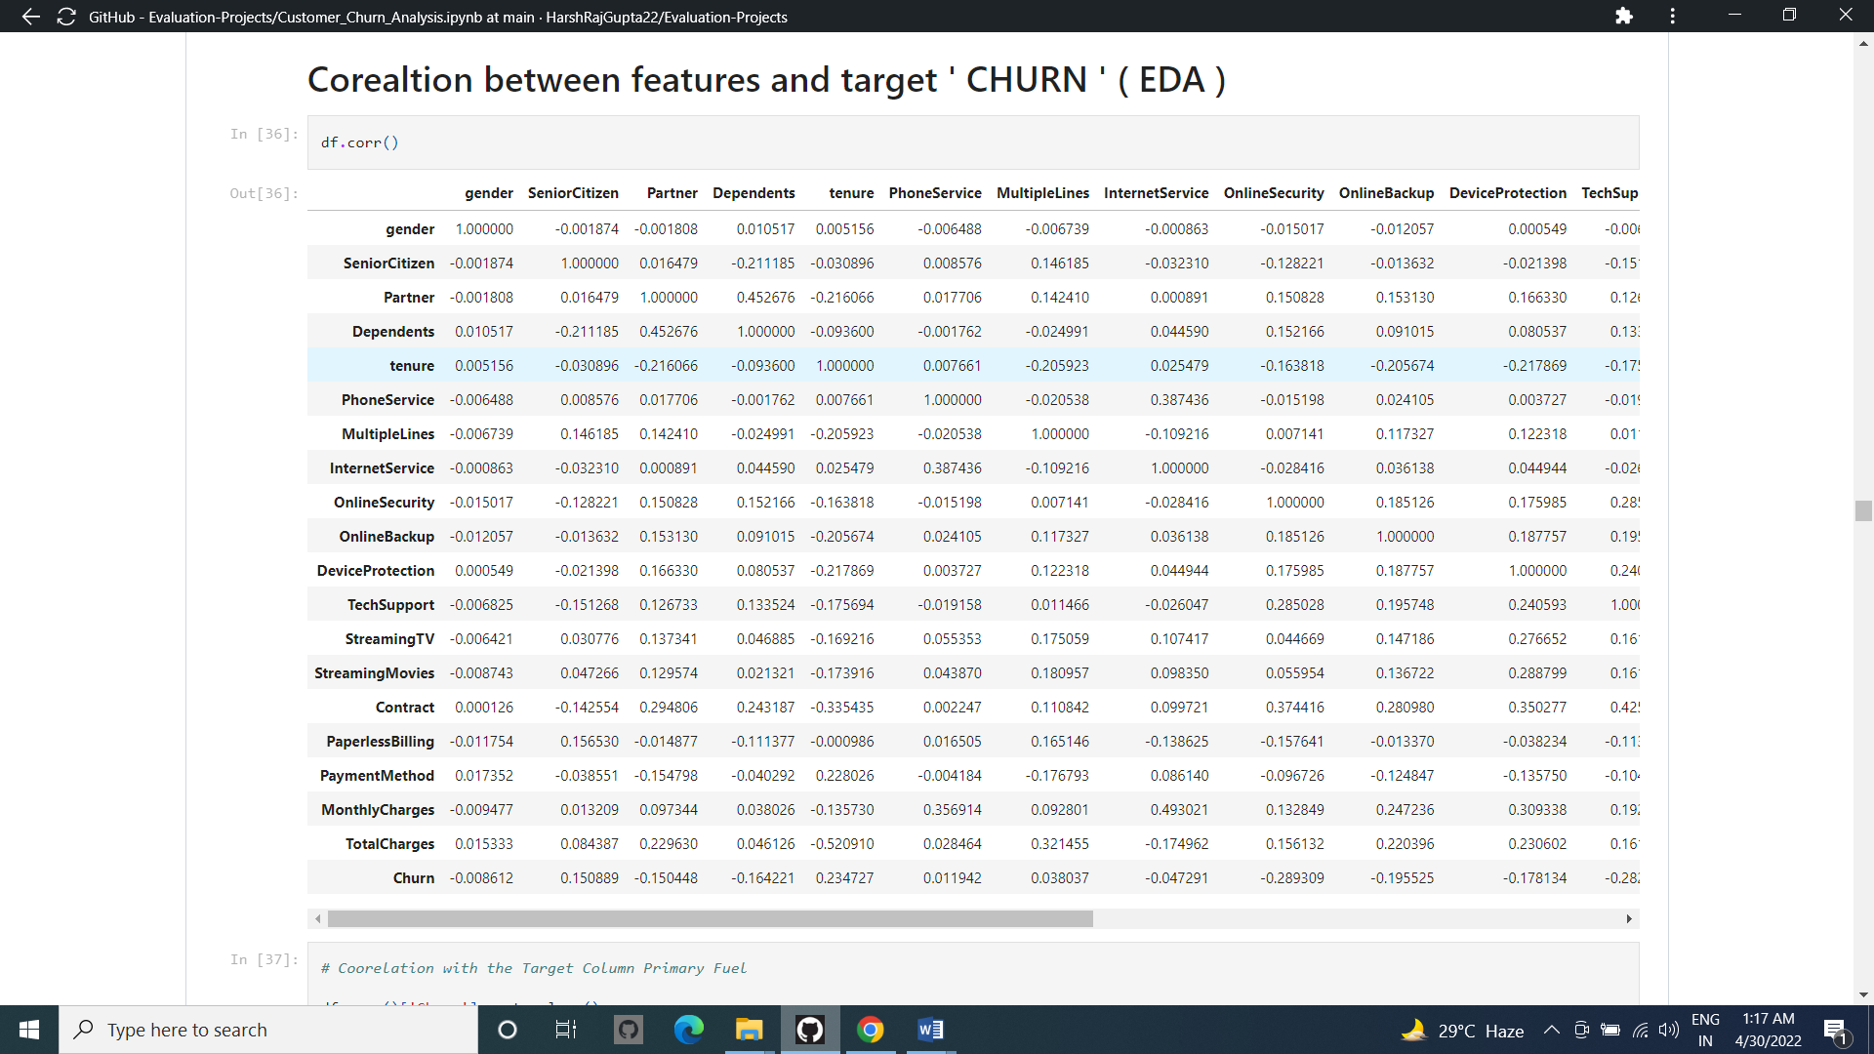

Checking the Correlation of Each Column With Respect to the All Columns present in the Dataset

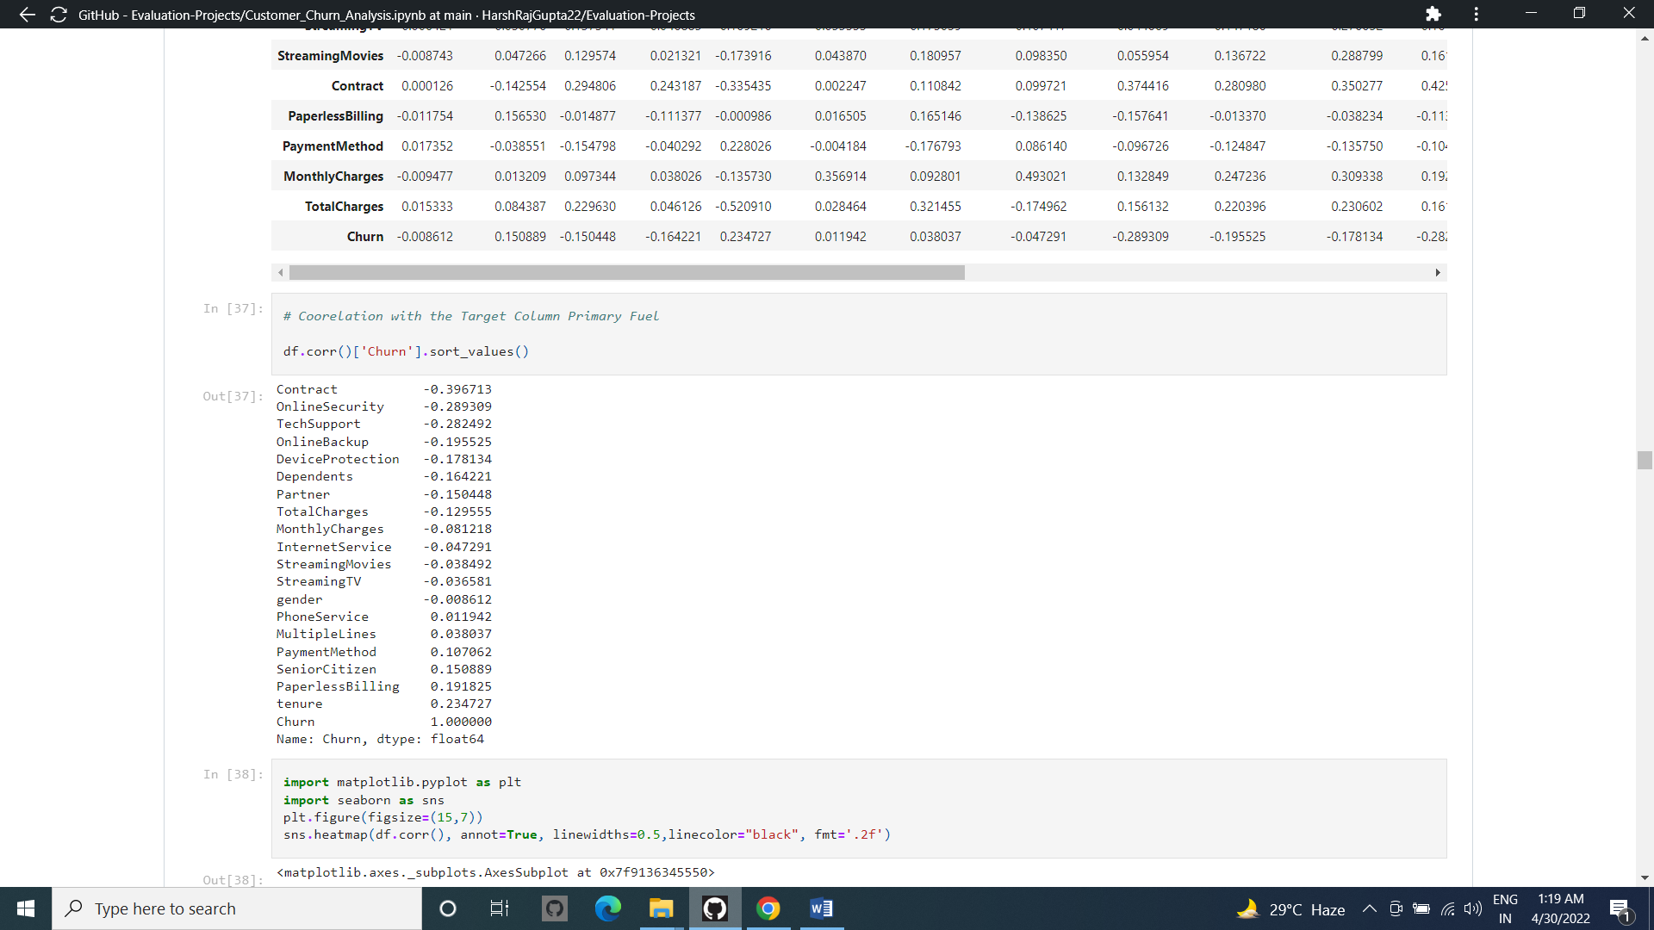

Checking the Coorelation of the target Column with All the Other Columns To find Out the least Coorelated Columns in the Dataset

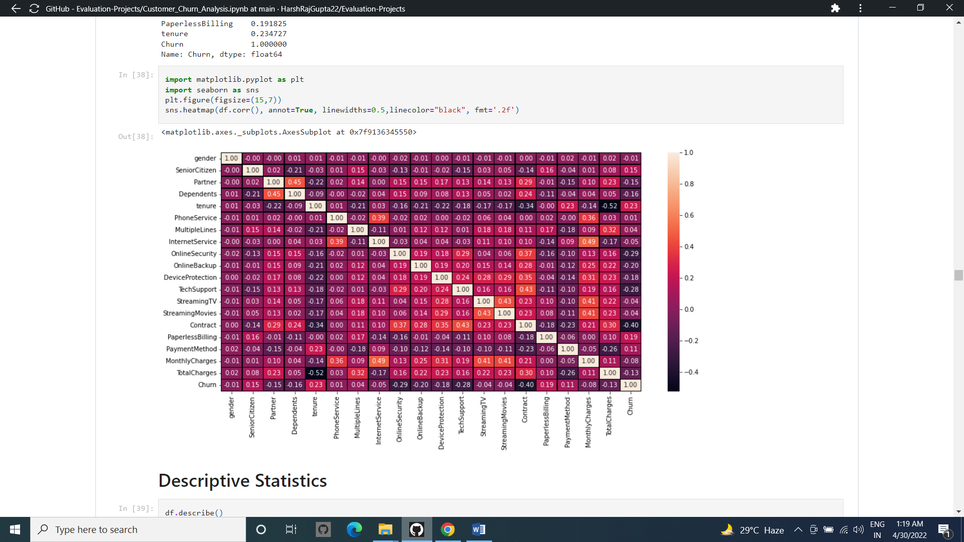

Checking the Coorelation of the Columns through Heat Map..

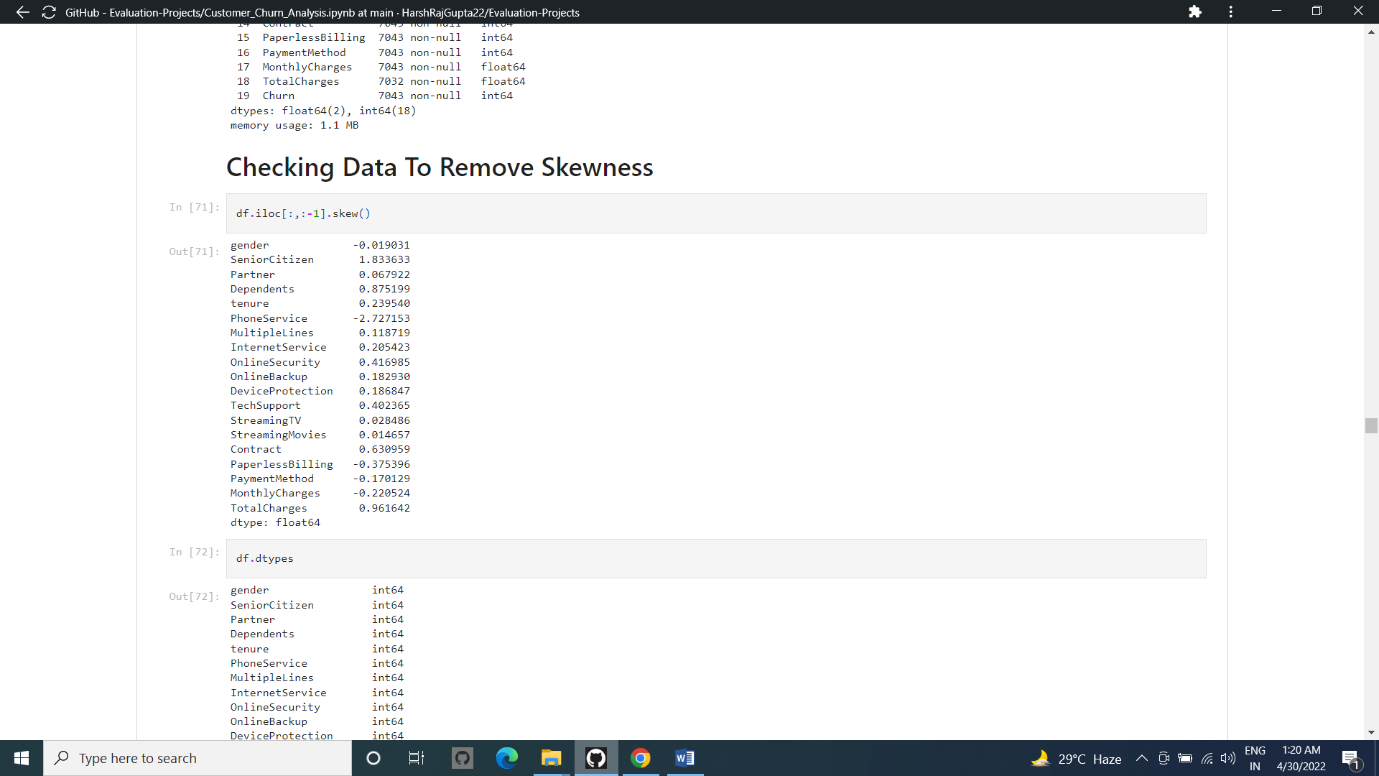

Considering the skewness Value as -/+ 0.5 as the limit for each columns..

As we Can see that there are Some Skewness present in the dataset We need to remove skewness for better training of the Model Excluding the Target Column..

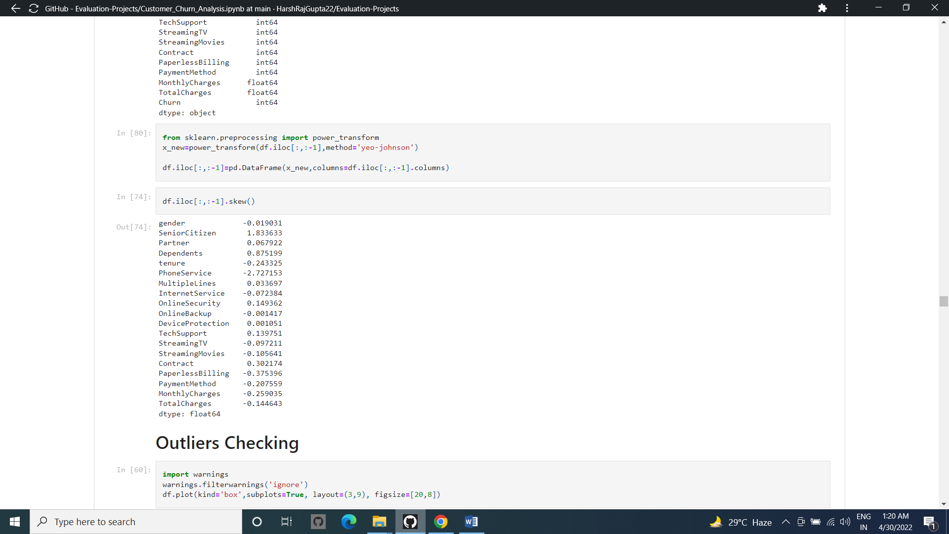

Removing Skewness Using ( YEO – JOHNSON ) Method from the Power Transform Library used for removing skewness from dataset Containing Both Negative as well as positive Values..

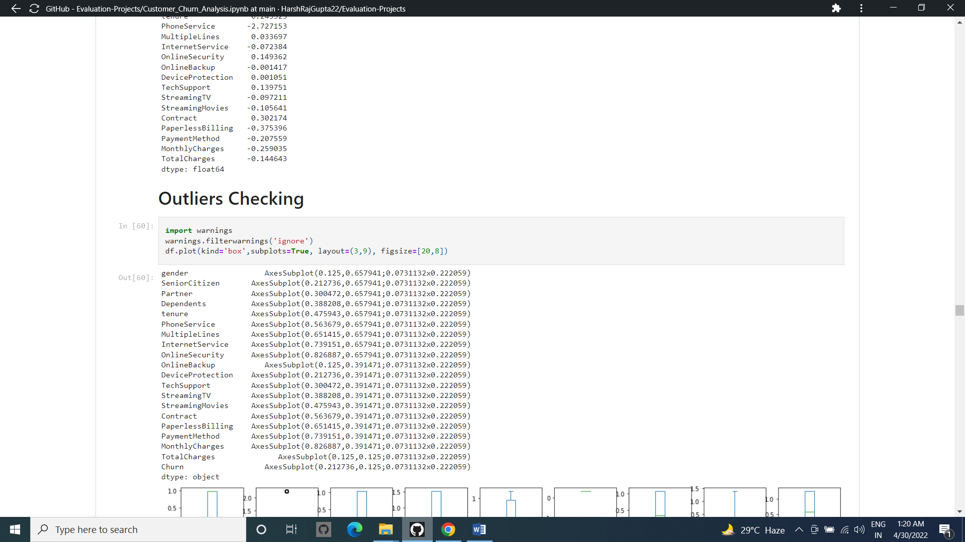

Checking For Outliers In the Dataset Present

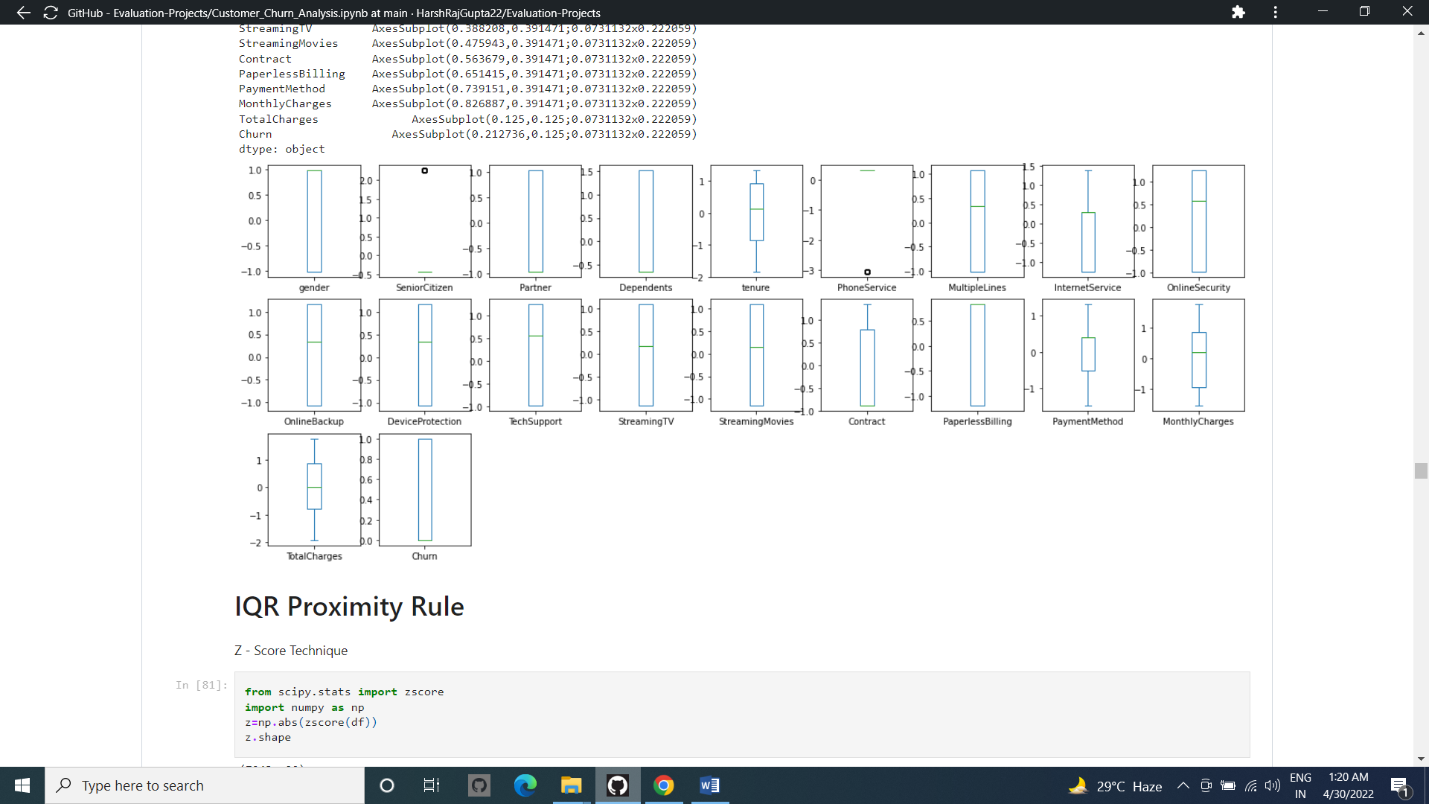

We can see that there are No Outliers Or Minimum Outliers present in the data Set present Which is Negligible..

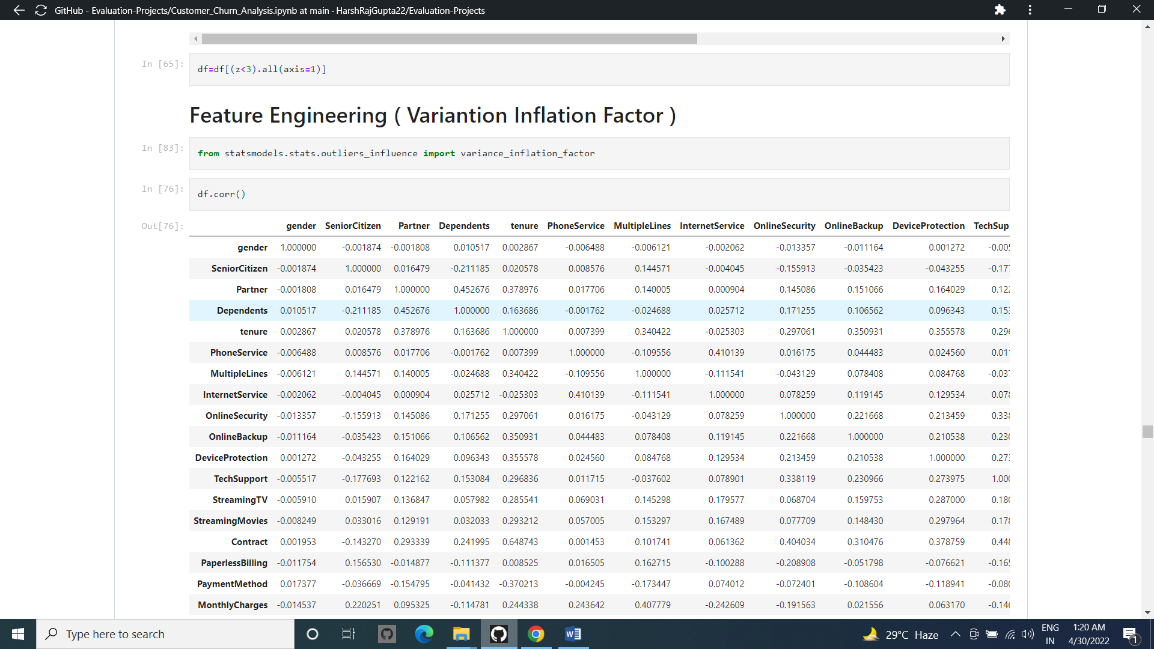

Checking forward for the variance Inflation Factor and removing the Highly Inflated Column Affecting the Model ..

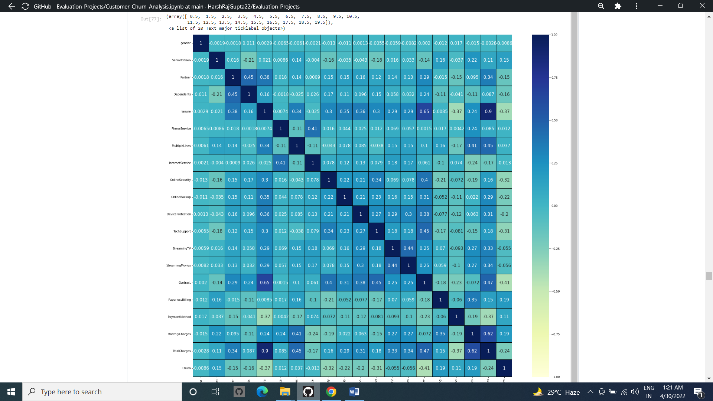

Checking The Variance Inflation Factor Through Heat Map..

I have plotted histogram after using Encoder and it only give the distribution of numerical

Columns present in our dataset.

I now feel the need to check for correlation details in our dataset through a Heatmap. For those who still feel a confusion on correlation details let me break it down in two simple points that there are Positive correlation - A correlation of +1 indicates a perfect positive correlation, meaning that both variables move in the same direction together and Negative correlation - A correlation of –1 indicates a perfect negative correlation, meaning that as one variable goes up, the other goes down. The code to see this information is displayed below.

Splitting the Columns in the Dataset for Futher Process..

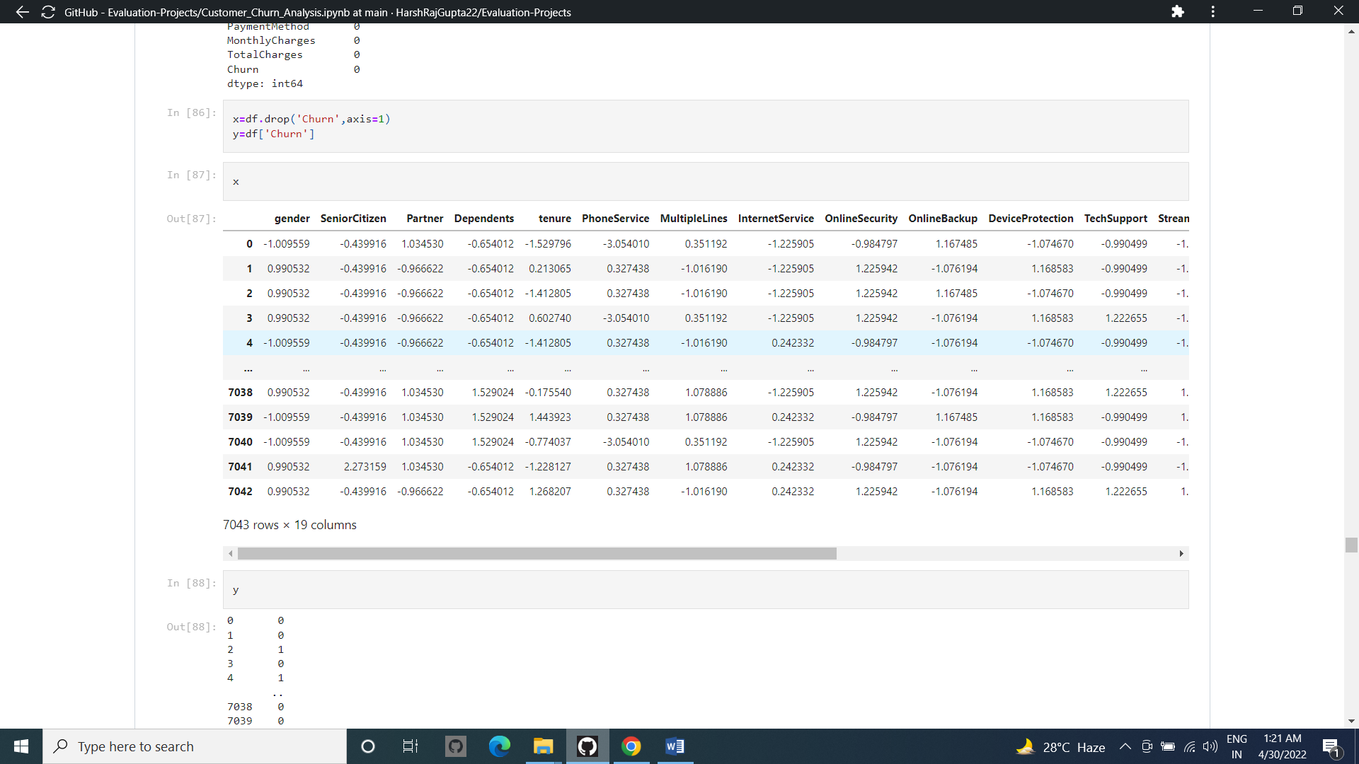

Removing the Target column from the Training Data to help to find out the Variance Inflation Factor And to Train The Model..

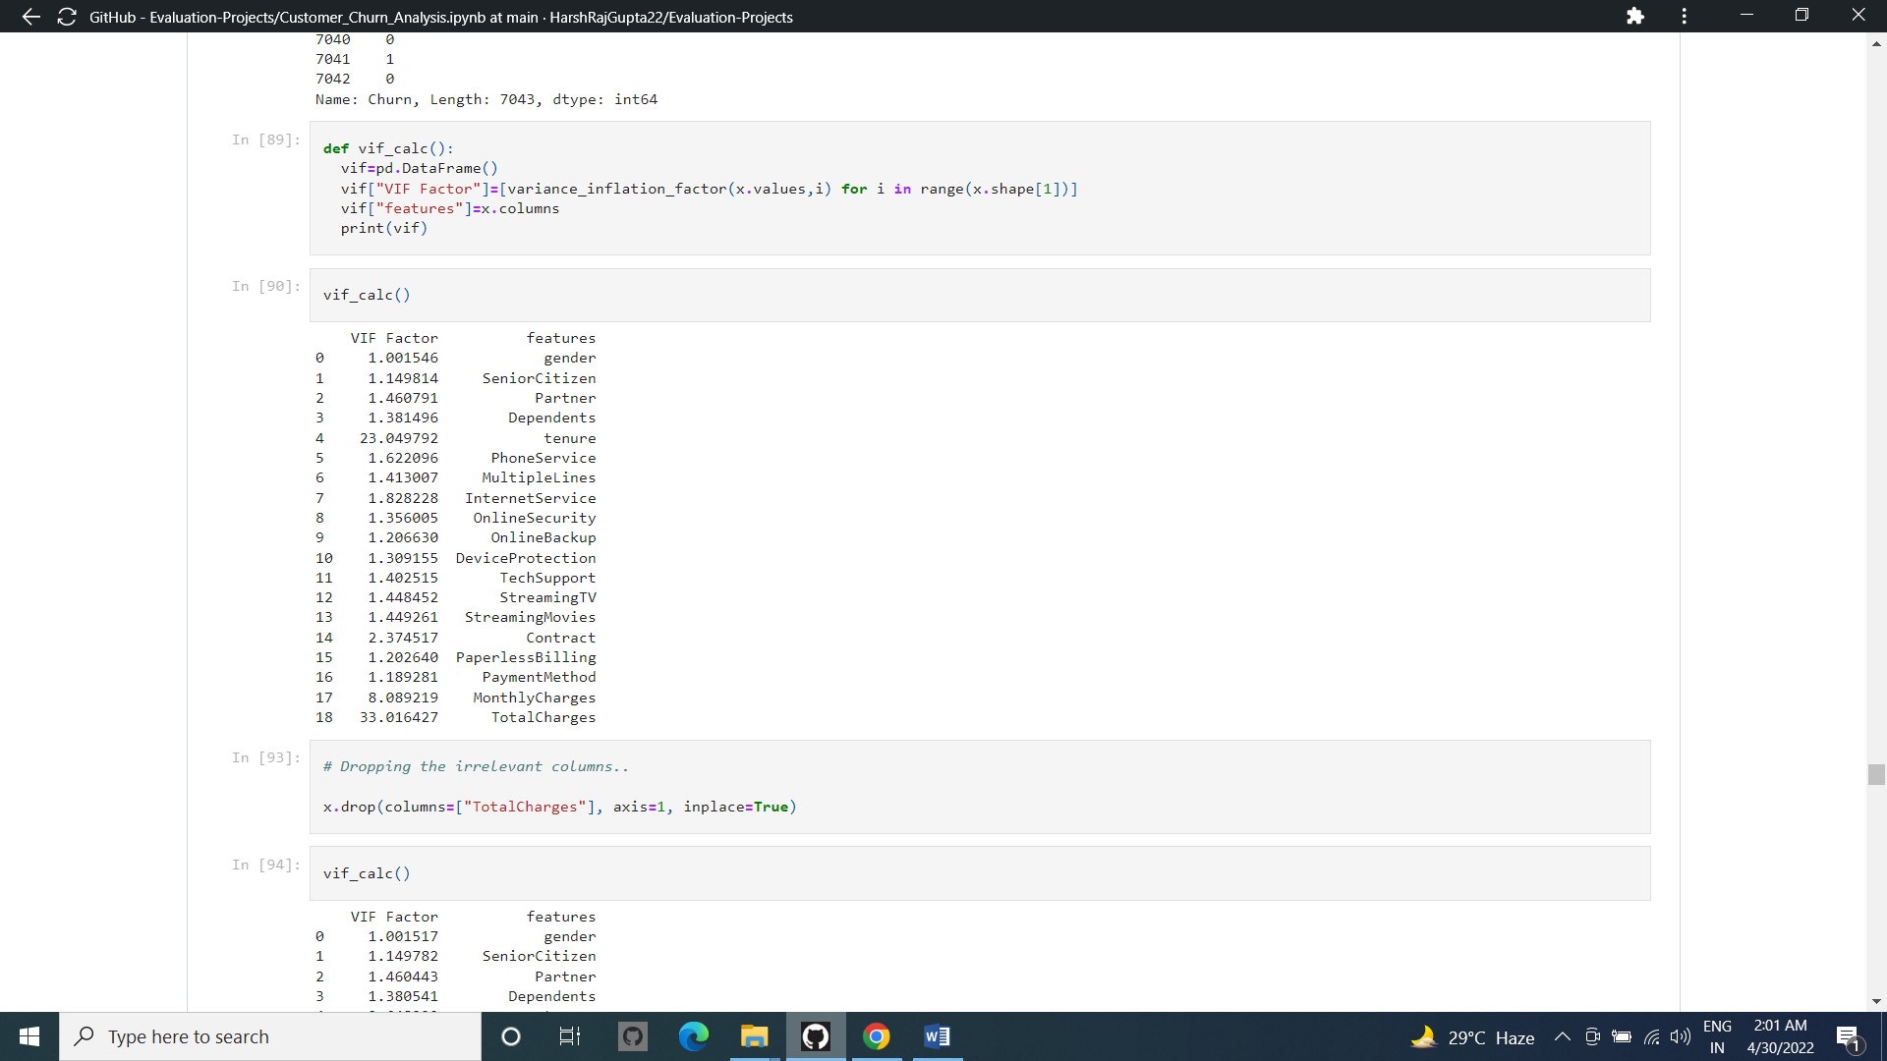

Calculating the Variance Inflation Factor of all the Columns in the Datsaset Excluding the Target Column..

We Set the Standard Variance Factor to 10 .. that means values abobe that Columns Should be Treated …

We Can see that Some Columns Have Values More than 10… Hence Droping the Highli Variance Inflated Column From the Training Datset ..

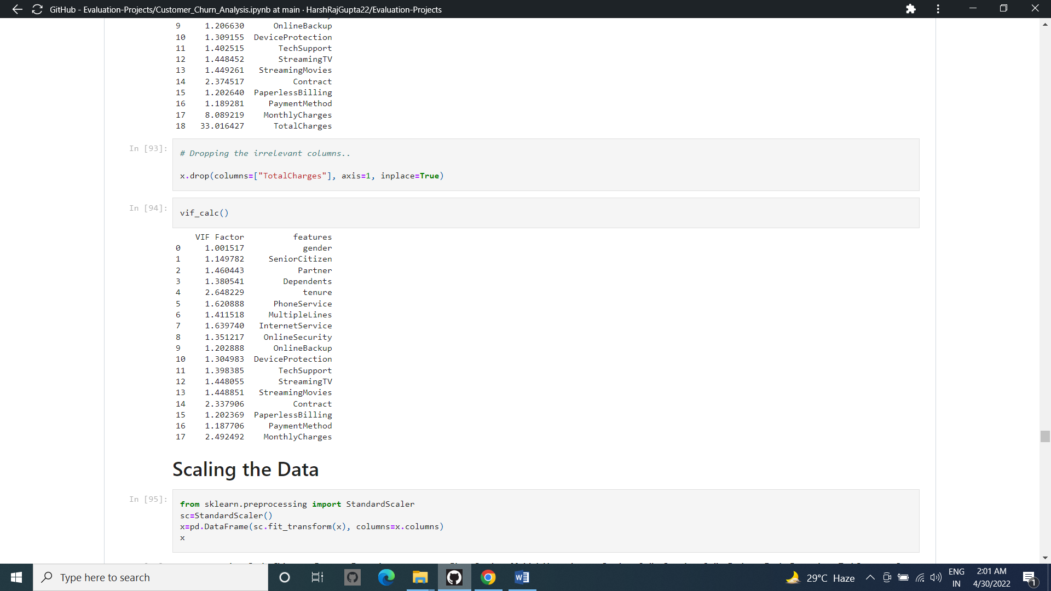

Removing the Column And Checking the Factors again to Check whether Inflation is removed Or not..

And We can see that after dropping one clumn From the dataset The Variance Inflation factor for all ..

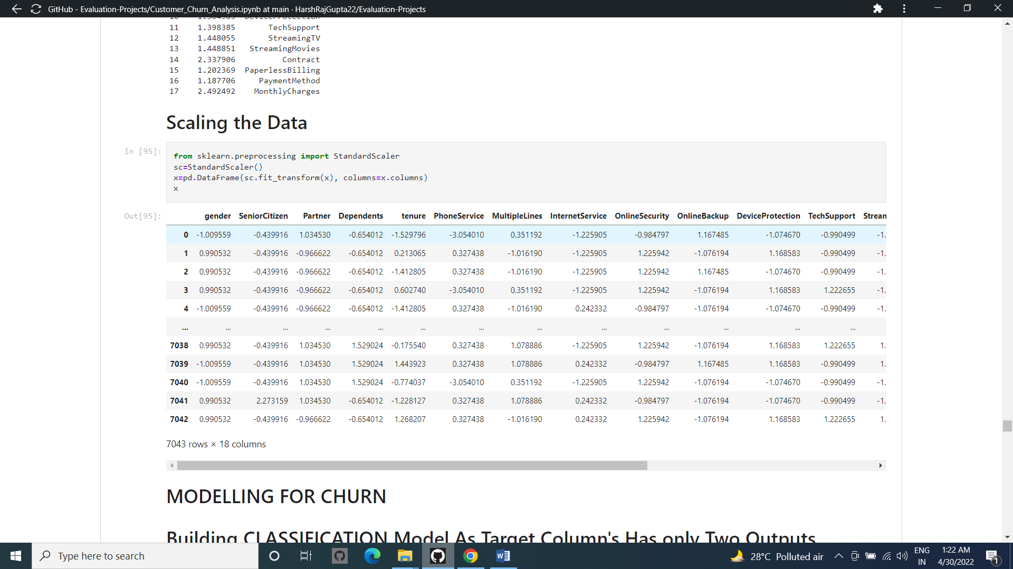

From the above standardScaler method we can scale that all the columns of our dataset so our dataset refrain from biasing for any particular column.

Scalint the data to make all the facors eaqual in the same scale ..

Any highly inflated Column will be Ninimized to low..

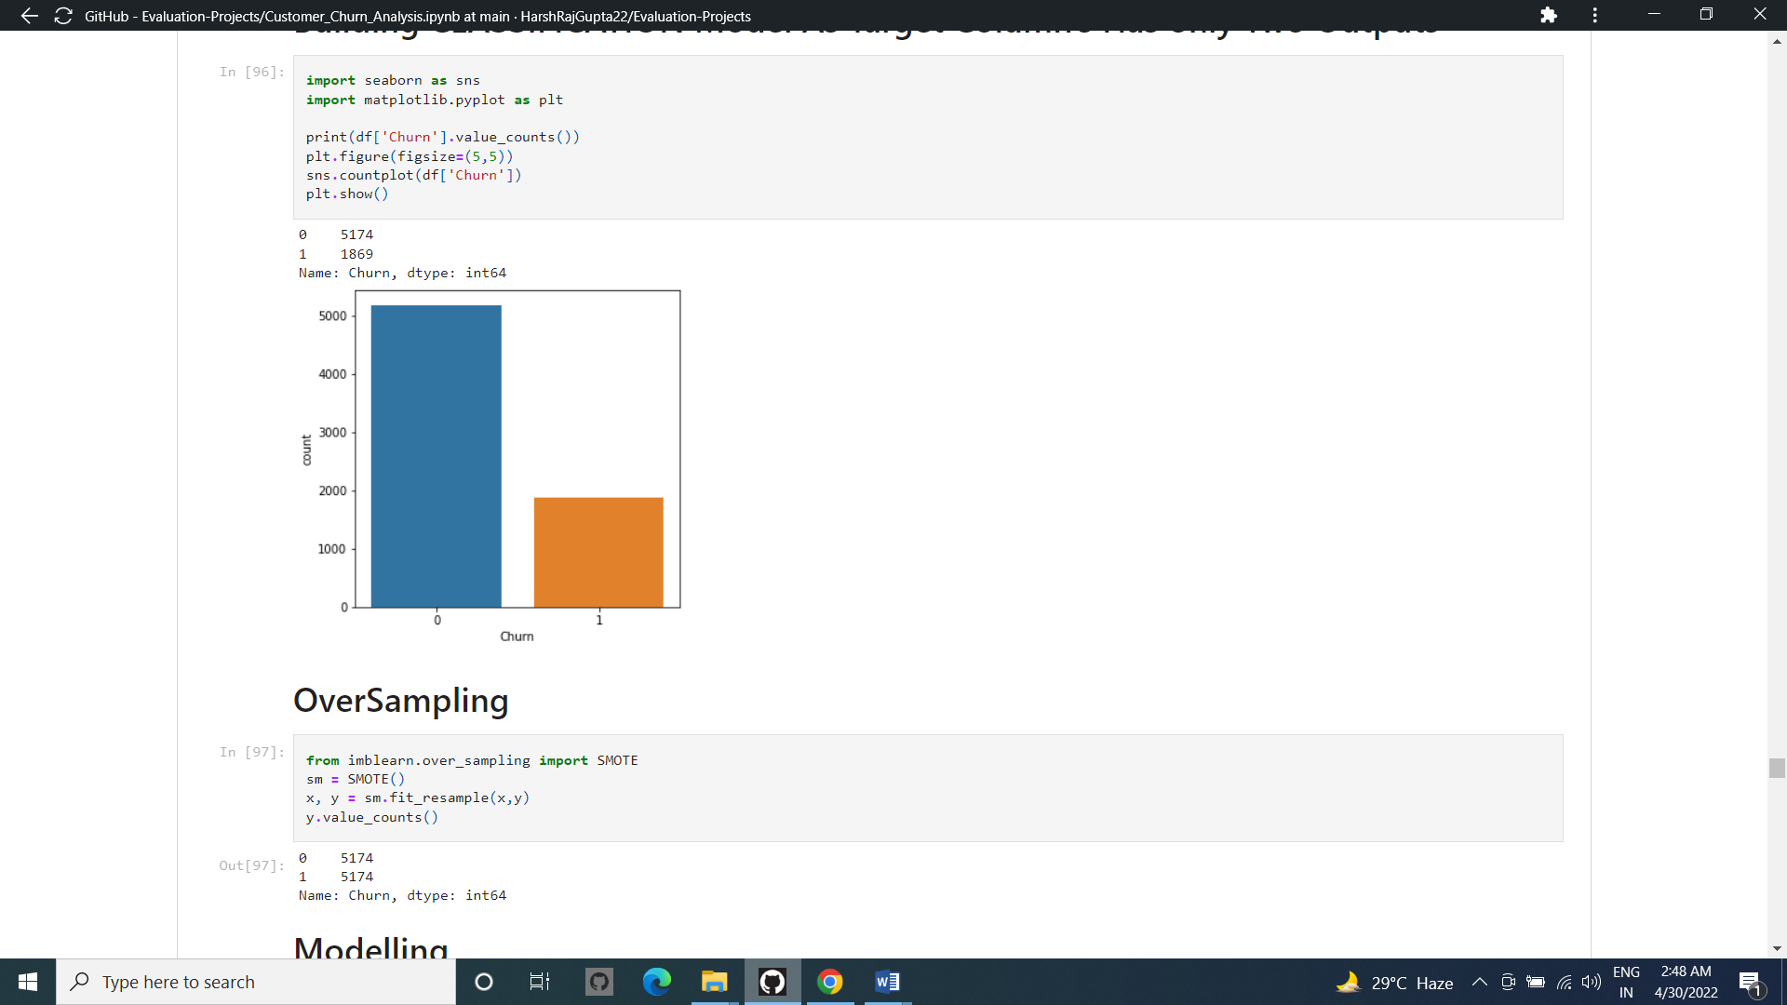

Checking for Over sampling of Target Column Before Traing The Column ..

And Removing it using SMOTE ..

1. Building Machine Learning Models

In order to build a classification method I have imported the necessary libraries and created a function that contains all our machine learning model creation and its evaluation metrics steps. This makes our job easier since later on we just need to feed the model’s name and get the result without repeating/rewriting the same code again and again.

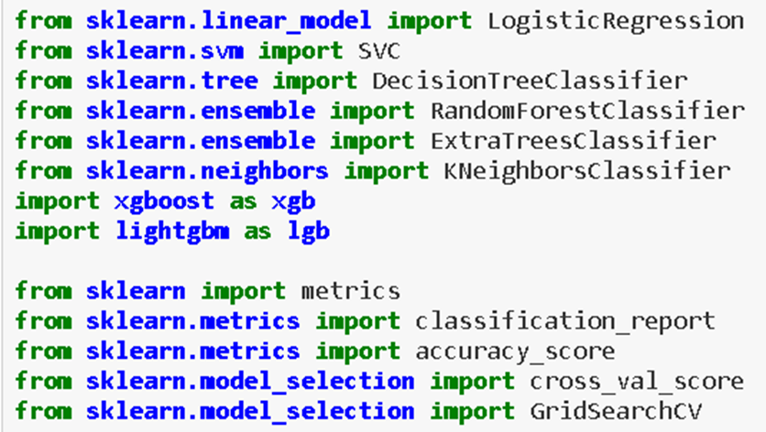

Importing all the Necessary Libaries Required For Model Training..

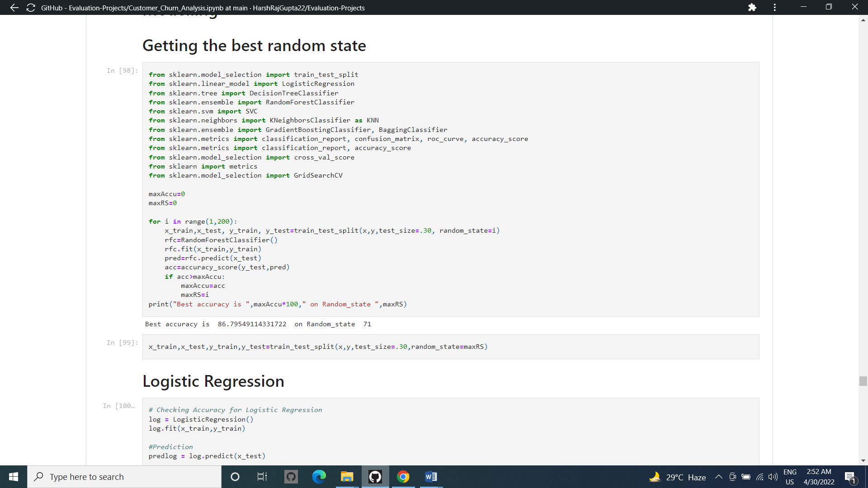

Training The Model To get The Best Random State ..

We can See that the Best Random state is &1 With An Accuracy Rate Of 87 %..



Setting the Train And Test Split Using the Best Random State..

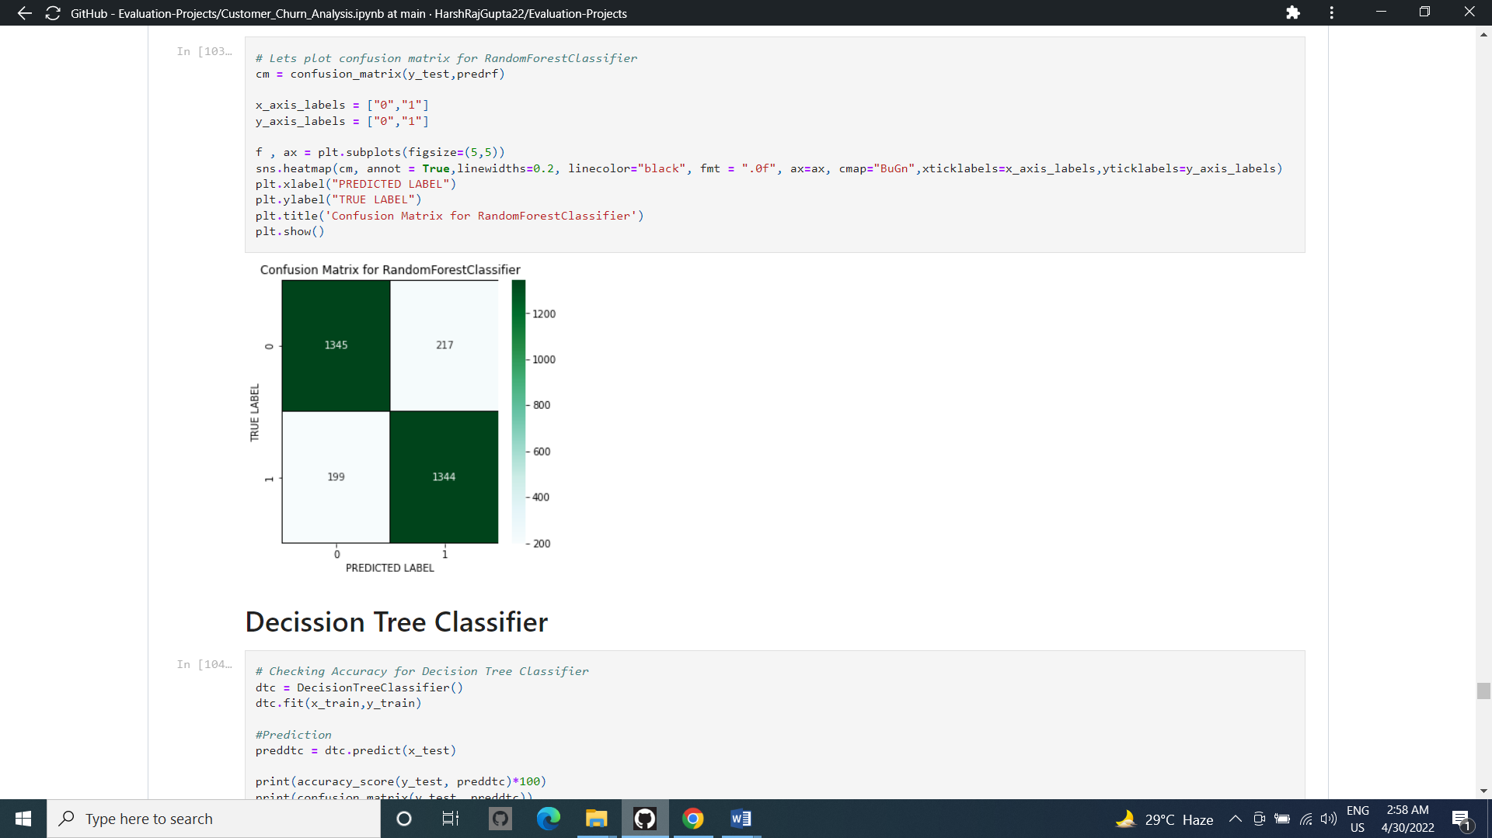

Plotting the Confusion Matrix For the Model..

WE can see that we have Total 1345 as True Positive And 1344 As True Negative Outputs in the data ..

After applying the above steps to get the best parameters list, I simply have to plug it into my final model and receive the output of it. I have created an ROC curve plot and Confusion matrix for the final model.

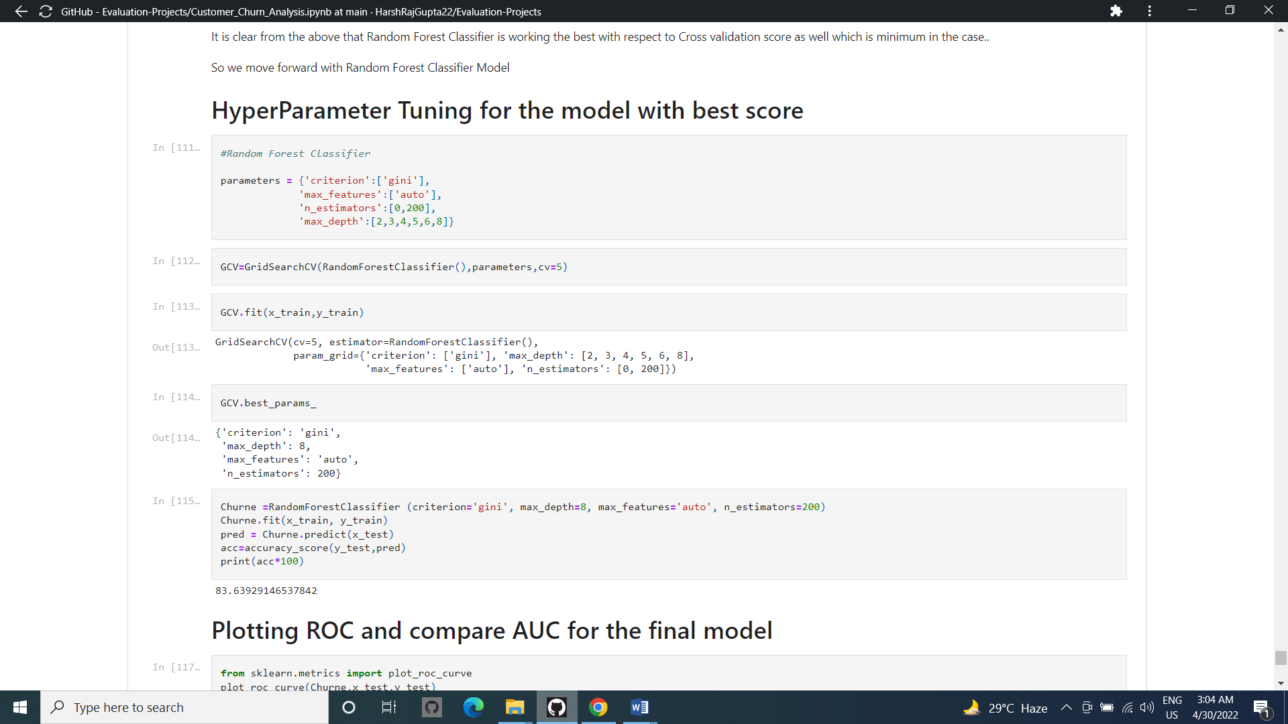

Training The Best Model Using Hyper Para Meter Tuning To Over Come Fitting Problems Such as Under Fit , Over Fit ..

And We got the Final Accuracy Rate as 84 %

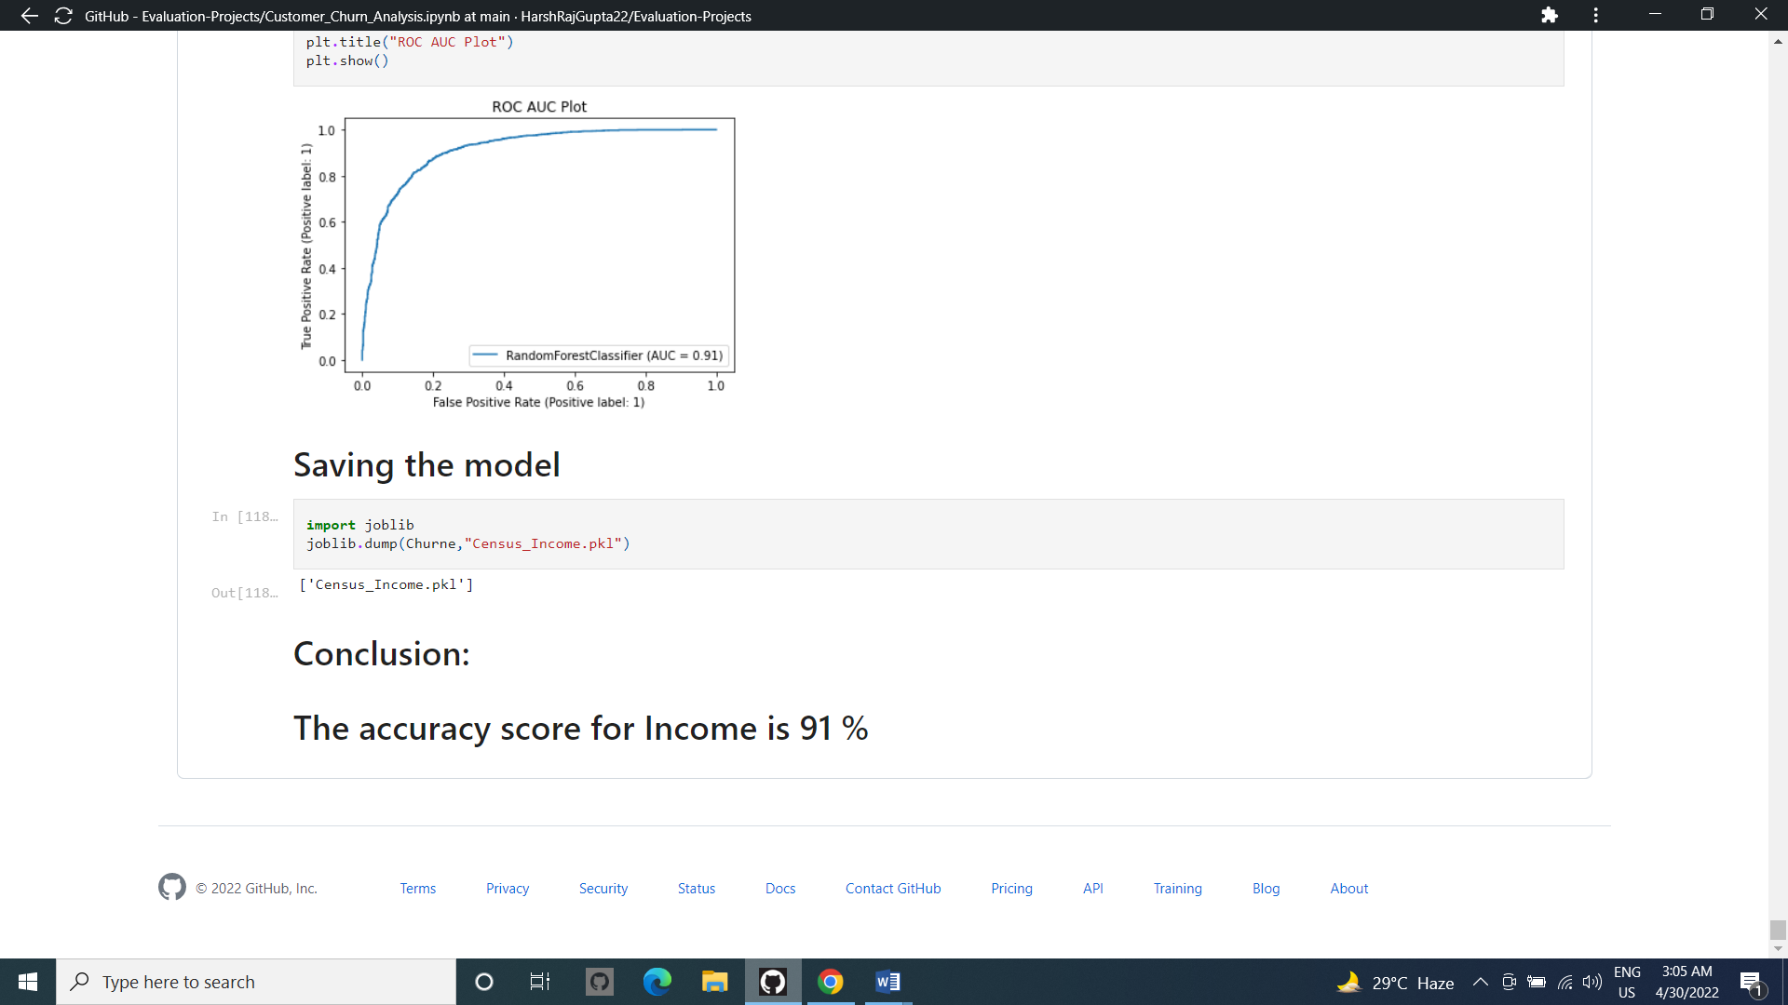

Plotting the AUC – ROC Curve For the Best model output From Model Training

**FINAL ACCURACY RATE 91 %**



Saving the Best Model.

**6.     Concluding Remarks**

Let me go back to each steps I have taken in this project. from beginning we have

Understanding the problem definition to go through EDA Processes . we went to some certain pre-processing steps and finally build Machine learning Model.

In this entire project I have given my best and put all possible potential that I have. Most of time I used my own code but when I found on internet some better code I opted that code.

I don’t take other good work on ego rather I do admire. Obviously , I do believe in learning by other project but yes it does not means that I copied the code.

For any of machine learning project my suggestion is first you have to understand the problem on ground level .if you don’t allow yourself to work with diligence .if you don’ t work harder anything that you are doing or will do , not only in case of machine learning but also in life cycle would be futile. Maybe, my endeavour assist you when ever you will get stuck

**Disclaimer**

I am new comer here in data science domain with some knowledge of 9 month. I have shared my effort in this blog to someone who is stepping in this field and can take some advantage from it . but to be honest it’s definitely inspired by others I saw many blog of this project on internet who have worked on this projects before me I just went through each of project and concluded my best way to make this blog.